CHAPTER

9 Kingdom Plantae

*Animation 9.1: Kingdom Plantae* [*Source & Credit: s*](http://anatomyeshs.wikispaces.com/Ch.16+Respiratory+System)[*torify*](https://storify.com/dedeayres/the-plantae-kingdom)

During the past few decades biologists have been trying to classify living organisms into various groups which could logically relect their similarities and dissimilarities at various levels. The groups were supposed to foreshadow the natural relationships among living organisms and their mode of origin. Such a system of classiication is called **Phylogenetic System of Classiication.**

Kingdom Plantae mainly includes eukaryotic, autotrophic, multicellular, non motile organisms which develop from embryos. Plant cells have cell wall outer to cell membrane which is composed of cellulose. There are about 360,000 known species of plants.

## CLASSIFICATION OF PLANTAE

For the sake of convenience organisms included in Plantae can be divided into two broad categories viz. non vascular **(Bryophyta)** and vascular **(Tracheophyta)** plants. Although this grouping is not according to any speciic system of classiication but it does relect similarities and dissimilarities among various groups of plants. Each category (division) is divided into Sub-divisions, Classes, Subclasses and other taxonomic ranks. Detailed discussion of classiication of Plantae will be beyond the scope of this book. Following is a brief outline of classiication of Plantae.

**Table 9.1: An outline of Classiication of Plantae**

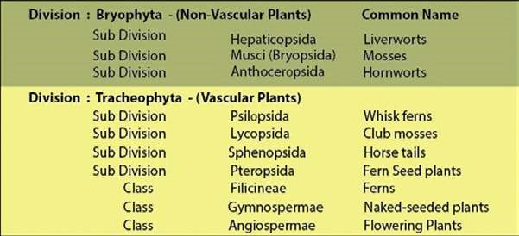

## DIVISION BRYOPHYTA

The irst plants to colonize land were the bryophytes. They are generally thought to have evolved from green algae.

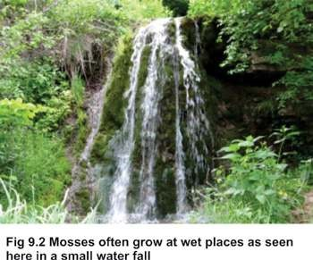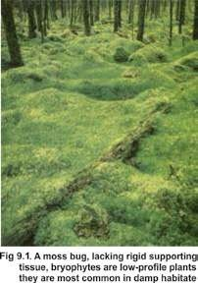

The Bryophytes are poorly adapted to live on land and are mainly conined to damp shady places (Fig. 9.1).

These plants are devoid of specialized conducting (xylem and phloem) and strengthening tissues. Only the process of difusion and osmosis helps in the transportation of water and minerals as well as in transportation of prepared food and other substances. The plant body is with a proper cuticle, or has a very thin one. The water is absorbed by the general surface of the plant. The bryophytes are said to be the **amphibians of the plant** world because they cannot live away from water. They need water for reproduction (Fig. 9.2).

The bryophytes are non- vascular lowerless plants. These plants show a regular a**lternation of heteromorphic (morphologically diferent) generations.** They have a dominant independent free living **gametophyte**. This may be thalloid as in many liverworts or is diferentiated into structures resembling to stem, leaves and absorbing and anchoring organs, **rhizoids**, as in mosses and some liverworts. The gametophyte produces a **sporophyte**, which is a less conspicuous generation, partially or totally dependent upon the gametophyte for its nutrition.

The sporophyte generally consists of foot, seta and capsule. The sporophyte is diploid (2n) which produces in sporangia one kind of haploid spores (i.e. it is **homosporous**) by meiosis.

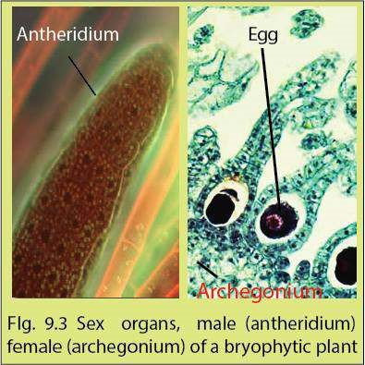The spores germinate and give rise to gametophyte which is also haploid. Multicellular male and female sex organs i.e. **antheridia** and **archegonia** respectively, are born on gametophyte either on same or diferent plants. These sex organs are multicellular and protected by a sterile covering of cells (Fig. 9.3).

Gametes are produced by mitosis. Male gametes produced within antheridia are called **antherozoids**; antherozoids are motile and always produced in large number. Female gametes formed within archegonia are termed as **eggs**. A single egg is formed in each archegonium. Fertilization takes place in water. Antherozoids (n) are attracted

towards archegonia (n) chemotactically. A single antherozoid fuses with an egg (n) thus accomplishing fertilization which results in the formation of the diploid zygote (2n). The zygote is retained within the female sex organ (archegonium) for some time. After a resting period the zygote develops through mitotic divisions into a **diploid embryo**. The embryo ultimately develops into a sporophyte which is also diploid.

The entire development of sporophyte thus takes place within the gametophyte plant body. Even when the sporophyte is fully developed it remains attached to the gametophyte for nourishment and protection because it does not contain chloroplasts and is unable to perform photosynthesis. There is an **alternation of generations** in the life cycle of bryophytes i.e. multicellular haploid gametophytic (gamete producing) generation alternates with the multicellular diploid sporophytic (spore producing) generation (Fig. 9.6). It is a very important phenomenon, which provides continuous genetic variabilities and selection for the best genetic make up for survival and adaptation in the changing environment(s) (as explained in a later section).

In view of the above mentioned discussion, bryophytes can therefore be deined more precisely as plants with the distinguishing characters as follows :

**’’Vascular system absent; gametophyte dominant; sporophyte attached to gametophyte; homosporous.”**

## ADAPTATION TO LAND HABITAT

In general bryophytes developed the following adaptive characters for terrestrial environment:

1. Formation of a compact multicellular plant body which helped in the conservation of water by reducing cell surface area exposed to dry land conditions. Presence of cuticle further reduces loss of water by evaporation.
2. Development of photosynthetic tissues into special chambers for the absorption of carbon dioxide without losing much water and exposure to light.
3. Formation of special structures like rhizoids for absorption of water and anchorage.
4. Heterogamy (production of two types of gametes) is evolved, forming non motile egg containing stored food and motile sperms.
5. Gametes are produced and protected by the special multicellular organs (antheridia and archegonia).
6. Multicellular embryo is formed which is retained and protected inside the female reproductive body during its development.
7. Alternation of spore-producing generation (sporophyte) with gamete producing generation (gametophyte) enabled the plant to produce and test the best genetic combinations for adapting to the versatile terrestrial conditions.

## CLASSIFICATION

Bryophytes are divided into three subdivisions : Hepaticopsida, Bryopsida and Anthoceropsida.

### Hepaticopsida (Liverworts)

Bryophytes belonging to this subdivision are called liverworts. It includes about 900 species. Liverworts are the simplest of all bryophytes (Fig. 9.4).

They are usually found on moist rocks and on wet soil. Since they live near water therefore chances of drying out are greatly reduced.

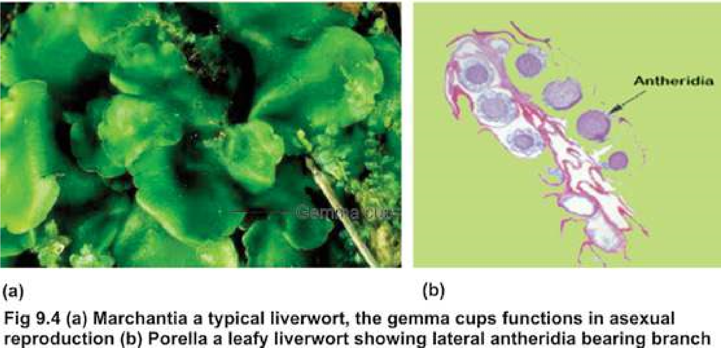

The plant body is a gametophyte. It may be thalloid i.e. lat, or ribbon-like, usually dichotomously branched. It is attached to soil by means of rhizoids e.g. *Marchantia*, Other species tend to grow upright and are falsely leafy i.e., diferentiated into a false stem, and leaves e.g., Porella (Fig. 9.4b). The sporophyte is dependent upon gametophyte! for nourishment and protection.

The sex organs develop on the upper surface of the thallus near the tips of the branches. Sometimes they develop on special branches on gametophyte called the **antheridiophores** and the **archegoniophores** as in *Marchantia* (Fig. 9.5).

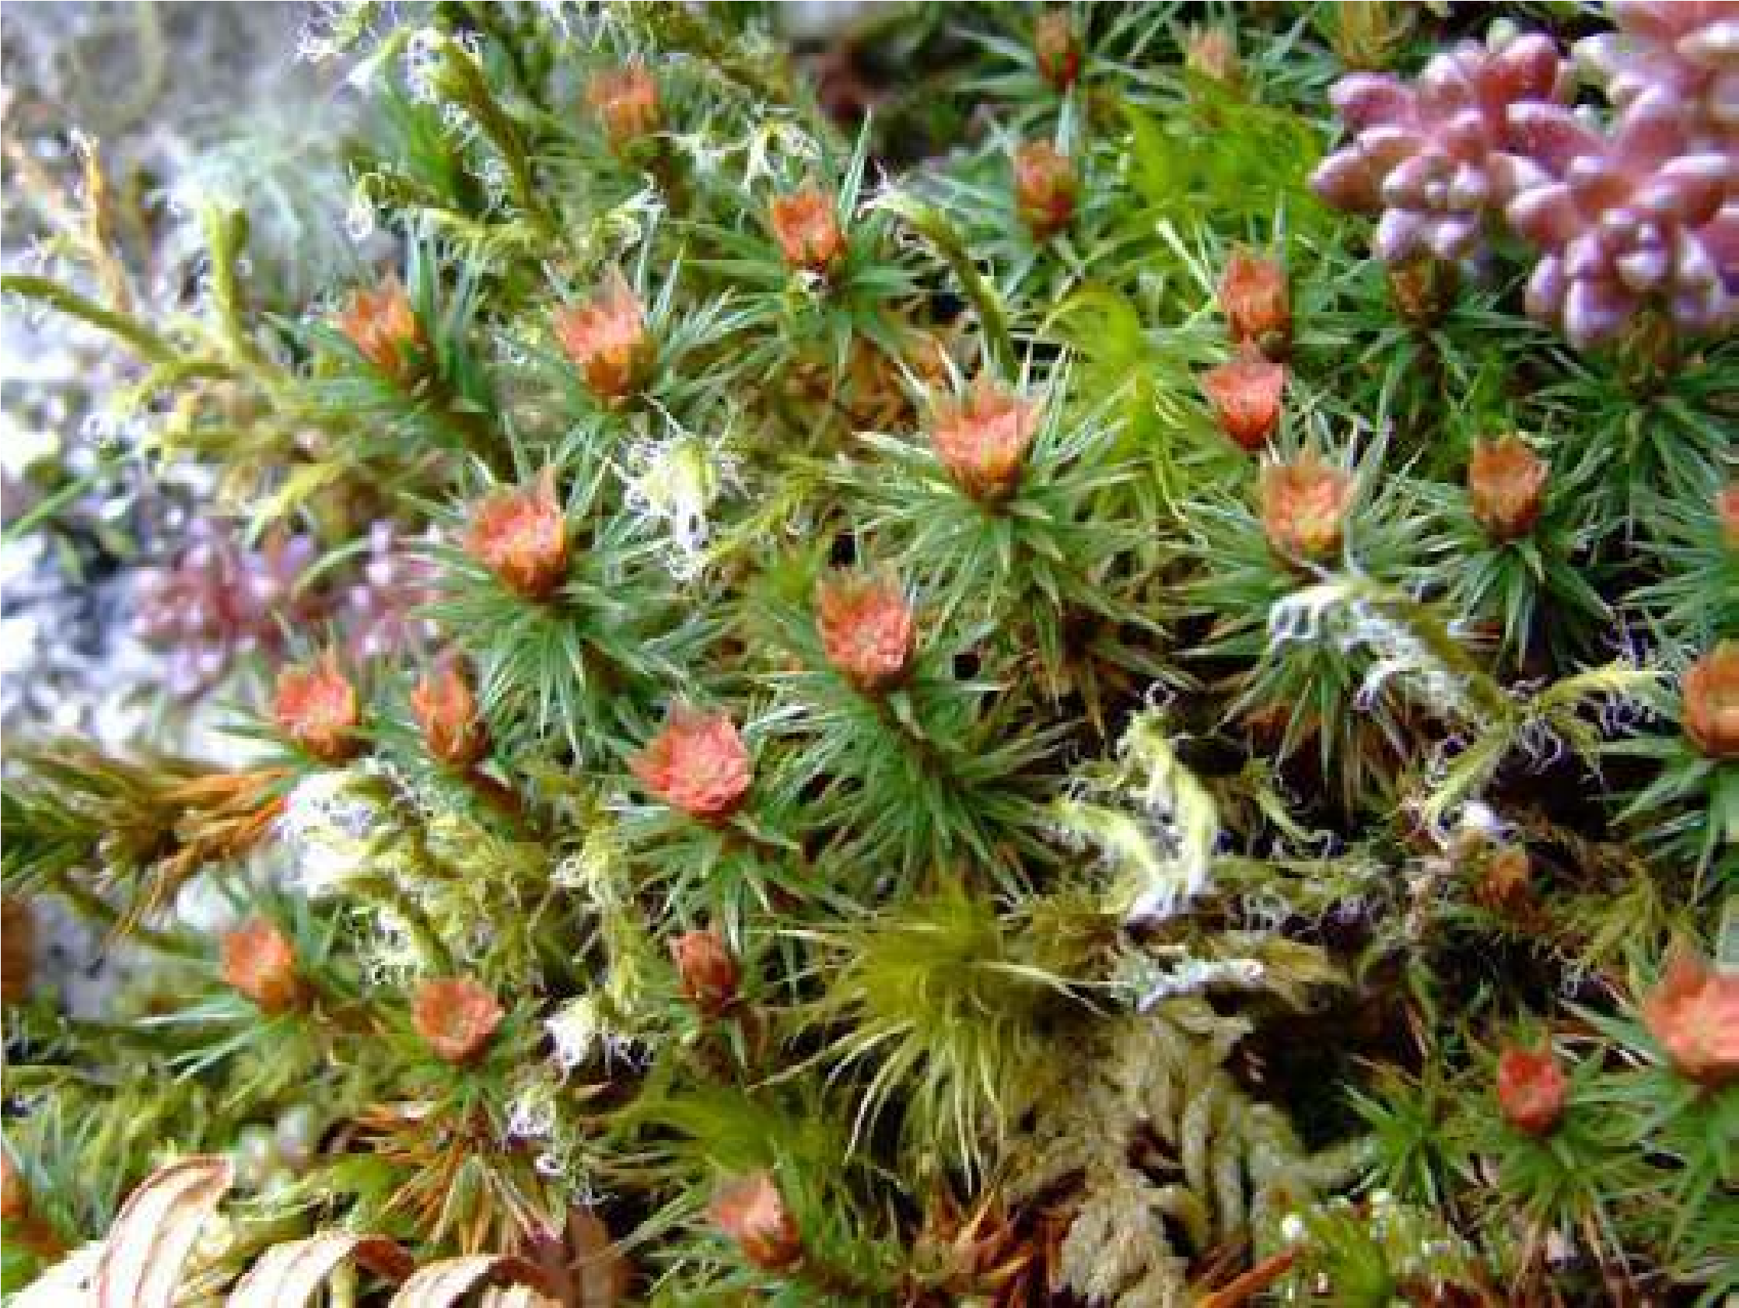

*Fig. 9.5 A Liverwort, Marchantia bearing sex organs, antheridia and archegonia, on special branches called antheridiophores and archegoniaphores:*

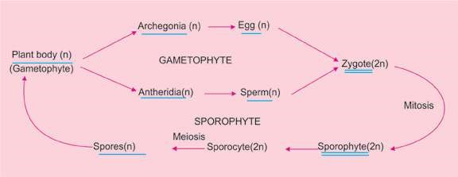

*Fig. 9.6 A generalized life cycle of a Bryophyte showing alternation of generation.*

### Bryopsida

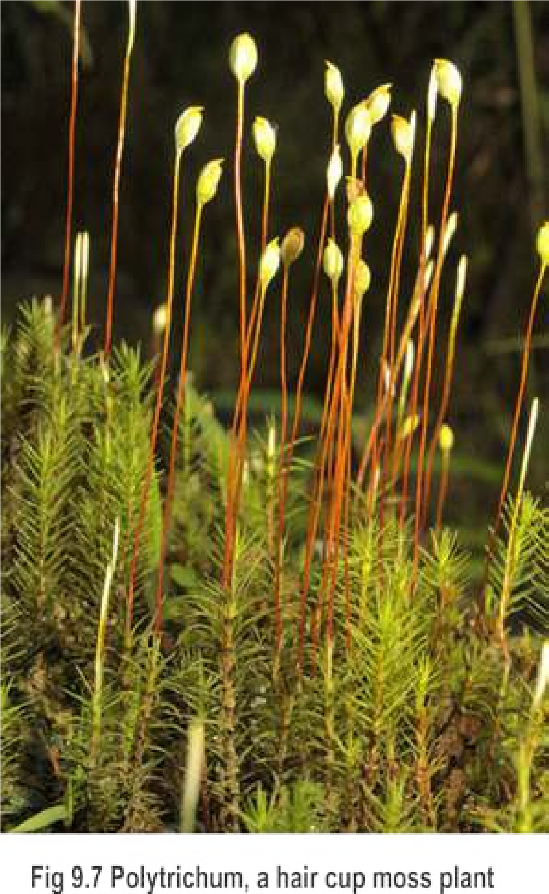Like liverworts most mosses inhabit damp places. In contrast to other bryophytes they grow equally well in fairly dry places. However, water is essential in the reproduction of mosses, thus they usually grow to form cushions or mats.

Each adult moss plant, a gametophyte, is always diferentiated into structures which resemble stem and leaves. Multicellular rhizoids are also present. Examples of mosses are *Funaria* and *Polytrichum* (Fig. 9.7). Archegonia and antheridia, develop on the tips of diferent branches on the same plant e.g., *Funaria*, or on diferent plants as in *Polytrichum*. The archegonia and antheridia form clusters and are mixed with sterile hairs, the **paraphyses**.

Formation of diploid sporophyte and haploid spores follow the same sequence of events of alternation of generations as in liverworts (Fig. 9.6). However, the spore of a moss, unlike that of liverworts, develops into an alga like structure, the **protonema**. Haploid moss plants (gametophyte) develop from buds on the protonema and the life cycle is completed (Fig. 9.8).

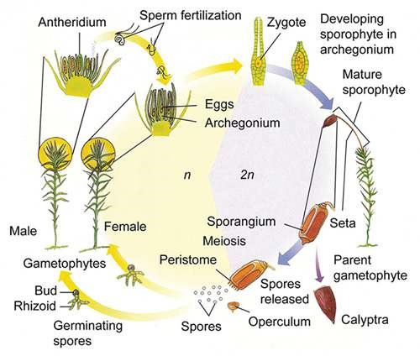

*Fig. 9.8 Moss life cycle*

### Anthoceropsida (Horn Worts)

This group of bryophytes difers in many respects and is slightly advanced than Bryopsida and Hepaticopsida. The gametophyte is highly lobed and irregular in outline. Except for a little early stage of development, the sporophyte is not dependent upon gametophyte for nourishment and protection. Antheridia and archegonia are partially sunken in the gametophytic tissue. The sporophyte exhibit many advanced characters due to which it can thrive better on land as compared to other groups. The sporophyte has stomata and chloroplasts in the epidermis and can thus photosynthesize its own food rather than obtaining it from gametophyte. It also has a waxy cuticle to check excessive loss of water (desiccation). Furthermore, at the junction of foot and spore producing region there is a band of **meristematic** tissue. This tissue keeps on adding cells towards the spore-producing region during the formation, maturation and dispersal of spores from the opposite end. Due to the fast growth rate of this meristematic tissue the sporophyte keeps on increasing in length for an indeinite period of time. Due to these characters the sporophyte continues to survive as such even after the death and decay of the gametophyte. One good example of Anthoceropsida is Anthoceros which is also found in the hilly areas of Pakistan (Fig. 9.9)

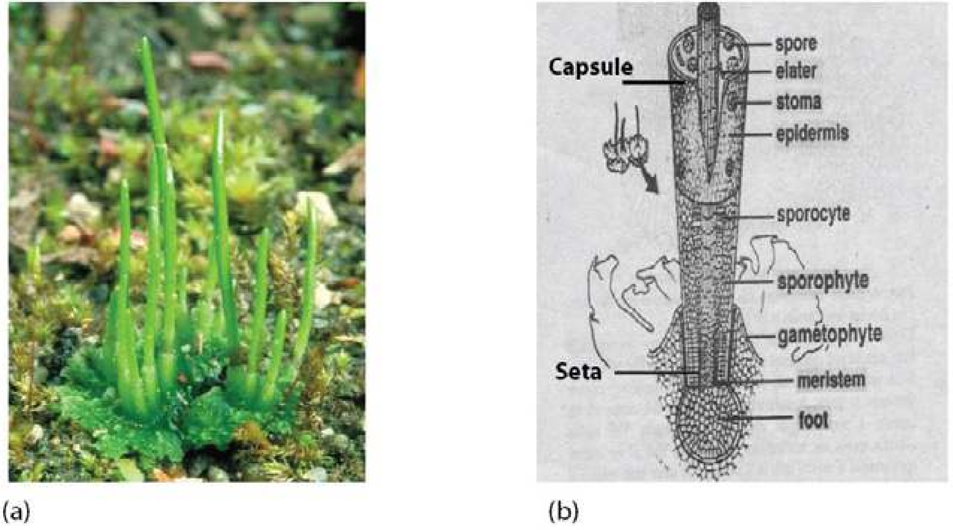

*Fig. 9.9 Anthoceros, a hornwort (a) Gametophyte with attached horn-shaped sporophyte (b) V.S. of sporophyte.*

### Alternation of generations

In the life history of liverworts, mosses and hornworts there are two distinct multicellular phases or generations. These generations are haploid **gametophyte** and diploid **sporophyte**, which regularly alternate with each other. The gametophyte is the dominant generation because it is more conspicuous. It produces gametes called **spermatozoids** or **antherozoids** and eggs, therefore called gamete-producing generation. A haploid spermatozoid fuses with a haploid egg to produce diploid **oospore**.

The oospore does not produce the gametophyte directly but produces a totally diferent plant called **sporophyte**. The sporophyte in bryophytes is a less conspicuous generation, which is usually diferentiated into **foot**, **seta** and **capsule** (also called **sporogonium**). Spores develop within the capsule by reduction division (meiosis) from spore mother cells. The sporophyte produces spores and is, therefore, called spore producing generation. The spore on germination does not develop into a sporophyte but gives rise to the gametophyte. Thus in the life-history of a bryophytic plant, the two generations, the gametophyte and the sporophyte, regularly alternate with each other. The phenomenon of alternation of gametophyte and sporophyte in the life history of a plant is called alternation of generations (Fig. 9.10).

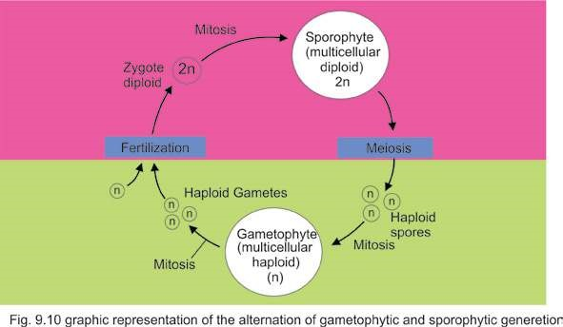

It should be noted that the gametophyte or haploid stage begins with spores and ends at gametes, whereas the sporophyte begins with oospore and ends at spore mother cell.

### The signiicance of alternation of generations

During the formation of spores from spore mother cells by meiotic division reshuling of genes occurs. As a consequence, a great variety of spores with diferent genetic make-up are produced. These spores in turn produce gametophytes with diferent genetic combinations. The gametophytes with better genetic make-up will have a better chance for survival in the environment where they occur. On the other hand, the gametophytes with less advantageous characteristics will be eliminated. There is no reshuling of genes during gametogenesis in the gametophyte as gametes are produced after mitosis.

The oospore developing after fertilization now has a new genetic make-up as compared to the parent. This genetic variation passes to the new sporophyte which on maturity once again produces further genetic recombination which are transferred to the gametophyte. In this natural process the sporophyte thus provide a large amount of genetic variability and nature selects the best genetic combinations. In the long run, this will allow the populations to become increasingly better adapted to their environment.

## DIVISION TRACHEOPHYTA

Tracheophytes are called vascular plants because of the presence of vascular tissues i.e. xylem and phloem.These are the successful group of land plants. They are able to adapt the rough land habitat most successfully and amongst them the lowering plants today have dominated land habitat. The evolution of following complex vegetative and reproductive characteristics enabled the vascular plants in general and lowering plants speciically to become predominant lora of land :

1. Root, stem and leaves.
2. Vascular systems in stems, roots and leaves.
3. Protected sporangia, leading to the evolution of seed.
4. Pollen tube for safe and water-independent transmission of male gamete to female gamete.
5. Flower and fruit.
6. Heteromorphic alternation of generation.

The Tracheophytes are further sub-divided into four sub-divisions, Psilopsida, Lycopsida, Sphenopsida and Prteropsida.

## PSILOPSIDA (PSILOPHYTA)

In Psilopsida plants have rootless sporophytes. The stem is diferentiated into an underground **rhizome** and an aerial part. Both are **dichotomously** branched. The rhizome bears rhizoids, both perform the function of root. The aerial branches are green, lealess and bear small veinless outgrowths and carry out photosynthesis. The reproductive organs of sporophyte are **sporangia** which develop at the tips of long or short branches, or on lateral sides of branches (Fig. 9.11).

Internal structure of stem is simple. Vascular tissue is narrow, central and soild without pith, with a broad cortex.

Psilopsida is considered to be the earliest group of vascular plants. Most of the representatives of this group have become extinct, for example, **Horneophyton, Psilophyton, Cooksonia** (Fig. 9.11) etc.

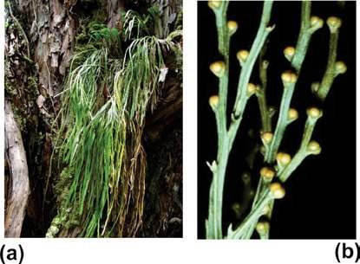

*Fig. 9.11 Psilotum*

1. *Dichotomously lealess branches.*
2. *The erect branches of another species, showing brown sporangia.*

There are only two living genera *Psilotum*, and *Tmesipeteris*.

The gametophyte is thalloid. It is colorless and underground. Its cells contain a fungus which provides food to the gametophyte and in return gets protection from it. Such beneicial symbiotic relationship among the two members (fungus and plant) is said to be symbiosis; or **mycorrhizal** association. Examples are *Psilotum*, and *Tmesipeteris*.

## EVOLUTION OF LEAF

Early vascular land plants did not have true leaves or roots. They were small in size, with dichotomously branched erect smooth aerial parts and equally strong subterranean anchoring and absorptive **rhizome**.

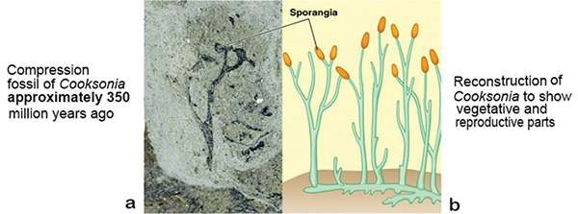

*Fig. 9.12 Cooksonia : an early vascular plant bearing sporangia at the tips of the branches.*

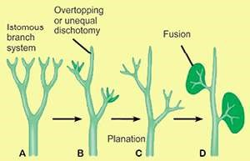*Cooksonia* (Fig. 9.12) had the same structural layout i.e. naked stem without leaves. Such plants started to form leaves as small scale like out growths. These out growths were not supplied with vascular tissues, therefore they were not regarded as true leaves. **Lycopods** were the irst plants that formed the true leaves and roots.

However in lycopods (e.g. *Lycopodium*) the leaves are small in size. Each leaf has a single undivided vein (vascular supply). Such a leaf is called **microphyll**. *Fig. 9.13 Successive evolutionary steps in the evolution of leaf.*

Large leaves having divided veins and veinlets

with an expanded leaf blade or **lamina** are known as **megaphylls**. Megaphylls are characteristic for ferns and seed plants. It is suggested that evolution of megaphylls started from a dichotomous branching system in some primitive psilopsids approximately 350 million years ago. It is assumed that evolution of a megaphyll included series of successive evolutionary steps (Fig. 9.13) which are as follows :

### Overtopping

The dichotomously branched aerial portion of the stem showed unequal branching. Some branches remained short while others grew and expanded at a much faster pace. All these branches grew in diferent planes. Such an unequal development of various branches is called **overtopping**.

#### Planation

Next important step was the arrangement of unequal dichotomies in one plane. This process is termed as **planation**.

### Fusion/Webbing

Overtopping and planation was followed by a process known as fusion or webbing. The space between the overtopped dichotomous branches was occupied by a sheet of parenchyma cells which connected these branches forming a lat lamina or leaf blade type of structure, having many **dichotomously** branched veins (Fig. 9.13).

During the course of evolution fusion of the vascular strands resulted in net or **reticulate venation** pattern. The process of evolution of leaf was very slow and gradual which completed in more than 15-20 million years.

## LYCOPSIDA

The plants of Lycopsida have sporophytes diferentiated into roots, stem and true leaves. The leaves are small and single- veined, they are also called microphylls. The arrangement of leaves is spiral or opposite. The sporangia develop singly on the upper side of the sporophylls, which may or may not be arranged to form strobili (Fig. 9.14)

The sporophyte may have sporangia of one kind as in *Lycopodium* or of two kinds i.e., microsporangia and megasporangia as in *Selaginella* (Fig. 9.15).

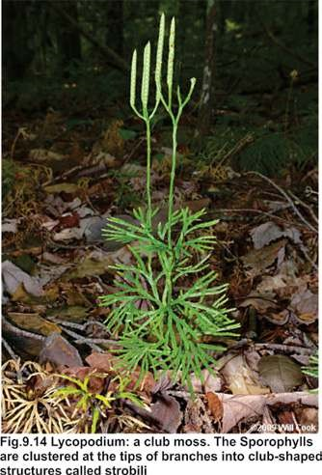

Lycopsids are also called club mosses/spike mosses because of their club/spike shaped strobili and small leaves resembling mosses. On the basis of types of spores produced in the sporophyte they are thus referred to as being homosporous’ or ‘heterosporous’ respectively. This condition is called homospory and heterospory. Selaginella resembles seed producing plants (spermatophytes) because of its heterosporic condition and some other characters. The gametophyte of Lycopsida is mainly underground.

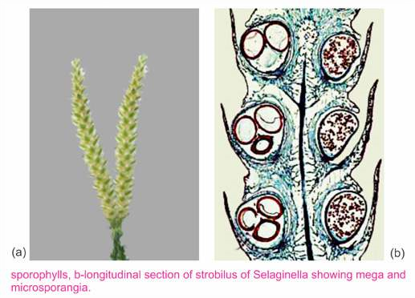

## SPHENOPSIDA

In Sphenopsida (Horsetails), the sporophyte is diferentiated into root, stem and leaves. The leaves may be expanded or scale-like and are always arranged in whorls. Plants belonging to this group are also called arthrophytes because the whole plant body is composed of large number of joints. Main stem is not smooth, it has large number of ridges and furrows. Each node has whorl of branches. The sporangia are born on structures called **sporangiophores**, aggregated to form strobili.

Each sporangiophore has a slender stalk and an expanded disc at its free end. The sporangia appear on the underside of the disc. The thalloid gametophytes grow upon clayey soil and on mud, e.g., *Equisetum* (Fig. 9.16).

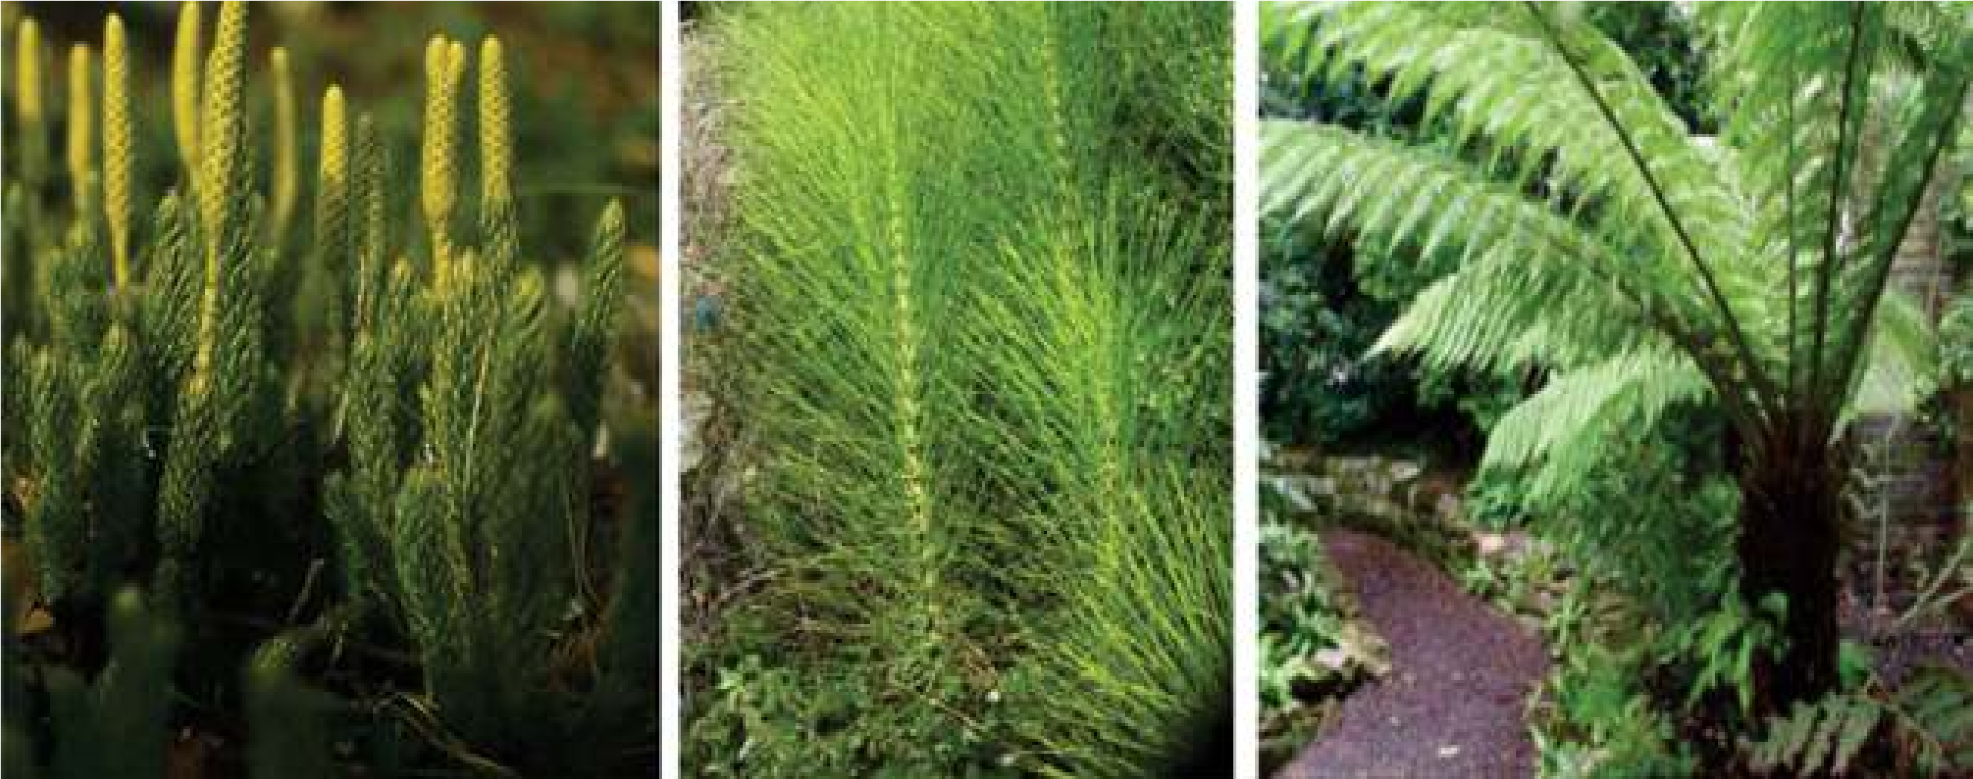

*Fig. 9.16 Representative of three of the subdivisions of vascular plants (a) club moss Lycopodium (b) A horsetail. Equisetum (c) A tree fern.*

### PTEROPSIDA

Pteropsida is divided into three classes (i) class **Filicineae** (ii) class **Gymno** **spermae** (iii) class **Angiospermae**. The class **Filicineae** contains seedless plants with foliar sporangia (sporangia attached to **fronds** Fig. 9.17). The leaves are called **fronds**. When the frond is immature and young, it is coiled, this pattern of development is called **circinate vernation** (Fig. 9.19). It is an important character of this group.

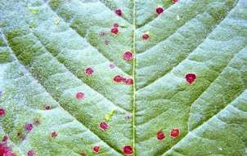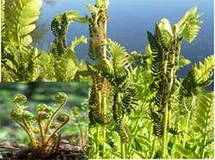

*Fig. 9.17 A frond bearing sporangia attached to the underside Fig. 9.18 Fems. A ostrich fem growing on a forest loor. See the of the leaf. coiled immature and young frondsready to uncoil.*

#### Class Filicineae

The Filicineae or fems are mostly shade and moisture loving plants. A very few are able to live under dry conditions. They grow on the hills and in plains. Some are epiphytic and grow on the bark of trees. Although ferns are worldwide in distribution, they are especially abundant in the tropics. They vary greatly in size. Important ferns are *Dryopteris*, *Pteridium*, *Adiantum* and *Pteris* etc.

##### Adiantum (Maiden-hairfern)

*Adiantum* is a fem that grows along moist walls and water courses. It is a small herb consisting of stem, roots and leaves. Stem is a short, thick and underground, usually unbranched horizontally growing **rhizome**. The rhizome is protected by brownish scales (ramenta) and covered by persistent leaf basis. Fibrous adventitions roots arise from the lower side of the rhizome. Large, pinnately compound fronds arise from the upper side of rhizome. Young leaves (iddle heads) show circinate vernation. The stipe (stalk) and rachis are black, smooth, shiny (hence called maiden hair fem). The lealets (pinnae, and pinnules - lealets of second order) show dichotomous venation. Sori (groups of sporangia) are born on the underside of relexed lobes of the margins of lealets, and are protected by bent margin of the lealet, forming false indusium.

**Life Cycle :** Life cycle of *Adiantum* shows hetromorphic alternation of generation, sporophyte being dominant and gametophyte small and reduced but separate and independent. The diploid sporophyte produce large number of sori (singular-sorus).They are green, but when ripe they become dark brown. Each sorus consists of a number of sporangia covered by false indusium. The leaves bearing sporangia are called sporophylls.

Each sporangium is slightly lattened, biconvex body (capsule) born on a multicellular stalk. The capsular wall consists of a single layer of lat, thin walled cells. The edge of the capsule is made up of two parts, the annulus and the stomium. The annulus occupies three fourth of the edge and remaining one fourth is the stomium. Annular cells have their radial and inner walls thickened. The stomial cells are thin- walled. Inside the sporangia, haploid spores are formed by reduction division, from diploid spore mother cells. The annulus of the sporangium contracts in dry weather, the stomial cells being thin-walled rupture and spores are dispersed by wind.

When a spore falls on a moist soil, it germinates at a suitable temperature and produces a haploid gametophyte or prothallus.

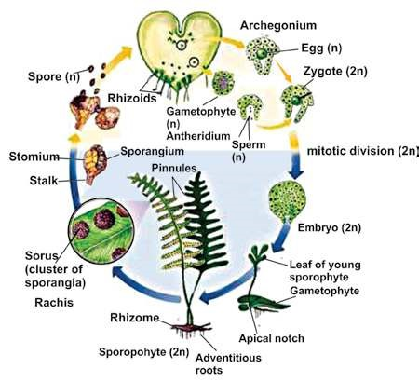

*Fig. 9.19 Life history of Adiantum*

The prothallus (gametophyte) is an autotrophic, small, lat, heart shaped structure. At the anterior end of the prothallus is a notch in which lies the growing point. Its size is about 8mm at its longest diameter. It is horizontally placed on the soil, and has unicellular rhizoids on its lower surface towards the posterior end. The rhizoids ix the prothallus to the soil and absorb nutrients for it. It is composed of rounded thin walled cells. The margin of the prothallus is one-celled thick but the middle part is many-celled and is cushion-like.

The prothallus is monoecious i.e., male and female sex organs appear on the under-surface of the same prothallus. In the mature prothallus, archegonia occur near the notch and the antheridia are scattered among the rhizoids.

Each antheridium produces numerous spermatozoids which are spirally coiled andmulticiliated..

The arcnegonium consists of a venter and a neck. The venter contains the egg or oosphere and is embedded in the cushion of the thallus. The antherozoids reach the archegonium, by swimming in water, Fertilization occurs and an oospore is formed. The oospore forms the sporophyte. Young sporophyte is irst attached to the gametophyte but later becomes independent. The life history of this fern is shown in Fig 9.19.

### EVOLUTION OF SEED HABIT

A review of the kingdom Plantae indicates that the seed-plants (spermatophytes) predominate over non-seed vascular plants.

One of the most signiicant events in the history of land plants’ was the development of seed habit. It was an important change in the reproductive system of the vascular plants which occurred approximately 390 million years ago. First complete seeds appeared approximately 365 million years ago during late Devonian times. Technically a seed may be deined as a fertilized ovule. An ovule is an integumented indehiscent megasporangium. Integuments are specialized protective coverings around megasporangium which vary in number. All seed producing plants are called spermatophytes. Various steps involved in the evolution of seed habit are as follows.

1. Evolution of heterospory.
2. Retention and germination of megaspore within the megasporangium.
3. Development of protective layers around megasporangium.
4. Reduction to a single functional megaspore per sporangium.
5. Development of an embryo sac within the sporangium.
6. Modiication of distal end of megasporangium for pollen capture.

#### 1. Evolution of heterospory

Primitive vascular land plants produced one kind of spores, a condition called **homospory**. All groups of land plants up to **pteridophytes** are **homosporous**. During the early phase of evolution some plant groups started producing two diferent types of spores, the smaller ones called **microspores** and the larger ones known as **megaspores**.

The microspores produced inside microsporangia germinate to form male gametophyte or the **microgametophyte**, whereas the megaspores germinated to form female gametophyte or **megagametophyte**.

##### 2. Retention and germination of megaspore within the megasporangium

During the usual reproductive cycle in the heterosporous vascular land plants, the megaspores are used to be shed and dispersed soon after their formation in order to germinate into female gametophyte. However in some plants (e.g. Selaginella) the megaspore is not allowed to escape from megasporangium immediately after its formation. In others the megaspore is permanently retained within the megasporangium. Here, within the conines of the megasporangium wall the megaspore germinates to form egg containing female gametophyte.

##### 3. Development of protective layers around megasporangium

Some branch like structures of sporophyte surrounding the megasporangium fused around to megasporangium to form protective envelope or integument. The megasporangium tightly locked by integuments becomes totally indehiscent. This important change led to the evolution and formation of the ovule, which is nothing but an integumented indehiscent megasporangium. In this way more protection is accorded to the egg-containing apparatus in terrestrial environment.

##### 4. Reduction to a single functional megaspore per sporangium

Each megaspore mother cell within a megasporangium used to produce four gametophytes. There was a competition for space and food among the four gametophytes. Soon the early vascular plants adopted a new strategy i.e., only one megaspore is selected for further development into a healthy female gametophyte while the remaining three are aborted.

##### 5. Development of an embryo sac within the sporangium

The single healthy megaspore retained within the megasporangium germinates to form an egg containing female gametophyte called an **embryo sac.**

##### 6. Modiication of distal end of megasporangium for pollen capture

When most of the structural and functional changes leading to the development of seed habit were completed, another important modiication took place in the megasporangium which was now integumented, indehiscent and permanently attached to - the sporophyte. The distal end of the megasporangium became modiied for capturing pollen (microspore containing male gametophyte).

Pollen after being trapped in the distal cavity of the megasporangium produces pollen tube which carry male gametes deep into the embryo sac to fertilize the egg, forming a zygote, that forms an embryo. The megasporangium (ovule) after fertilization is transformed into a seed, the integuments becoming the seed coats.. The seed ofers maximum degree of protection to a developing embryo under the unfavorable terrestrial environment. The development and evolution of seed habit was a great success and a giant leap which ultimately enabled Plants to colonize land permanently.

#### Class Gymnospermae

Gymnosperms are one of the successful groups of seed plants of worldwide distribution They constitute about one-third of the world’s forests. The gymnosperms are heterosporous plants which produce seeds but no fruits. The term gymnospermae literally means ‘naked seeded’ (Gymno= naked, spermae= seed). The ovules in these plants are usually borne on the exposed surfaces of fertile leaves (megasporophylls). These ovules, unlike those of angiosperms are not enclosed but lie naked on the surface of fertile leaves.

Like Filicinae, they show regular heteromorphic alternation of generations. They have independent, dominant sporophyte but less conspicuous, dependent gametophyte. The female gametophyte is permanently retained within the ovule. The two kinds of spores are microspores and megaspores which develop on microsporophylls and megasporophylls respectively. The megasporophylls bearing ovules are not folded and joined at the margins to form an **ovary**. For this reason the seeds lie naked on the mega sporophylls, (Fig. 9.20a).

The important genera are Cycas (sago-palm) (Figs. 9.20-a), *Pinus* (Pine), *Taxus* (Yew), *Picea* (Hemlock) and *Cedrus* (deodar) *Ginkgo* (Fig. 9.20-b) etc.

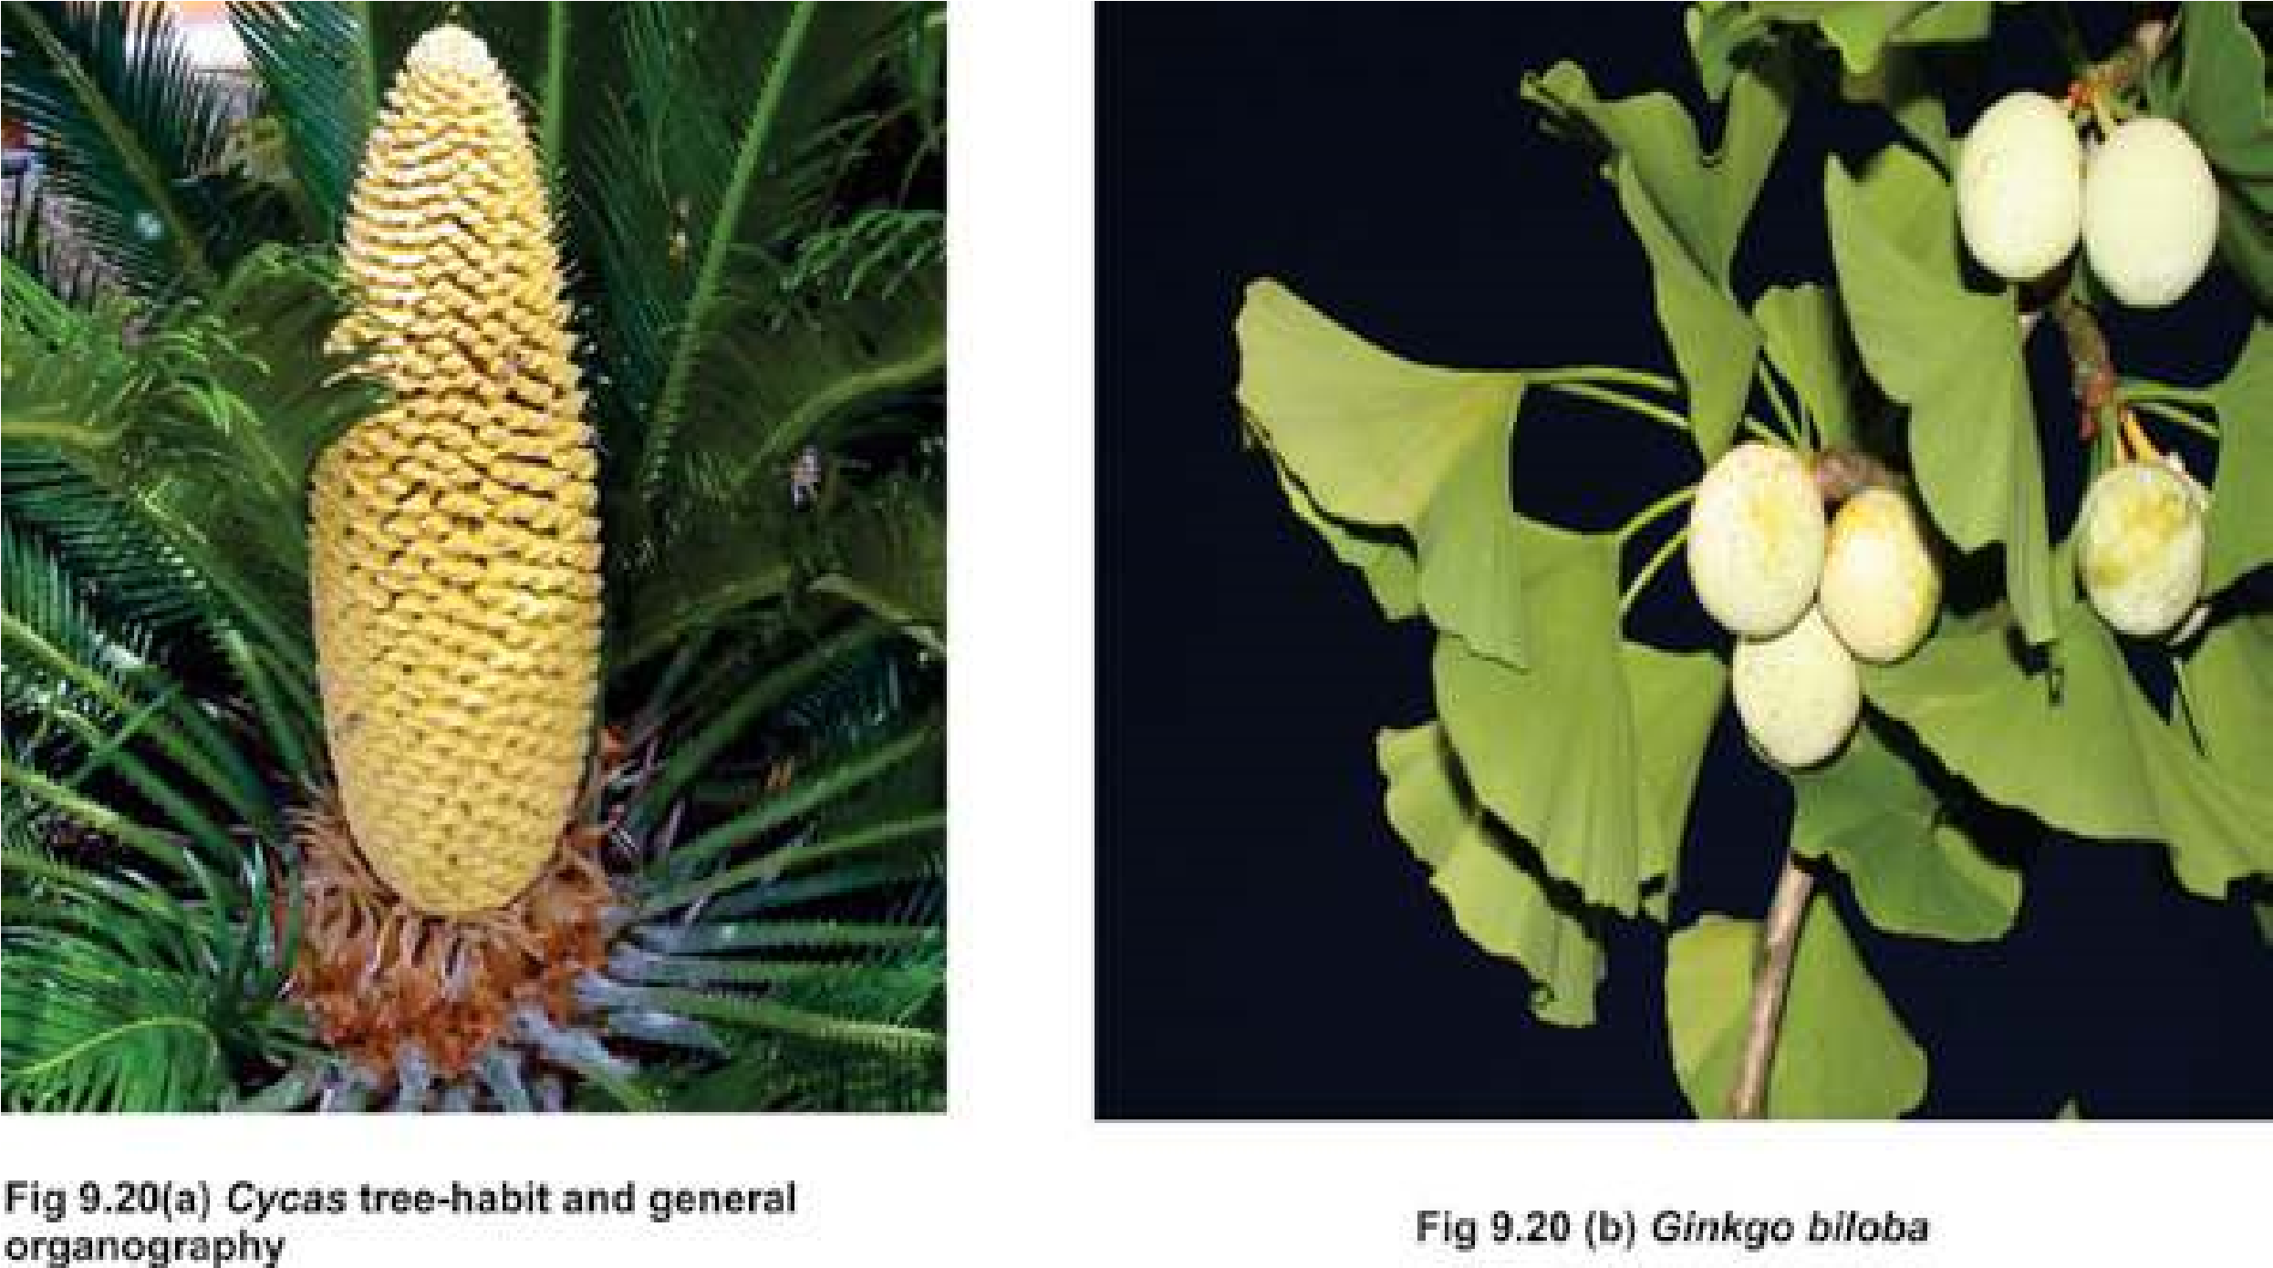

#### Pinus- Life Cycle

The Pine is a conifer. The main plant body is sporophyte which produces spores after reduction division of spore mother cell in sporangia. Conifers are heterosporous. Microspores and megaspores are produced in microsporangia and megasporangia respectively. Sporangia (i.e., micro and megasporangia) are produced on respective cones (male cones and female cones) on the same plant.

The male cones are small in size and are produced in clusters on an axis. Each male cone consists of microsporophylls which contain microsporangia. Microspore germinates to form a small inconspicuous male gametophyte (also called as microgametophyte) within the spore wall. Such a microspore of seed plants that contains the microgametophyte including the gametes is called a pollen grain (Plural = pollen).

Pollen are produced in great numbers and are transported by wind. Pollen grain in Pinus has two wings attached to its lateral sides. Due to wings, pollen can loat in air for a longer period of time and ean travel long distances. The gymnosperms have successfully evolved this totally new mechanism of transfer of male gamete to the female gametophyte through wind which has made them independent of water for this purpose. This is an important improvement and evolutionary adaptation to survive in the harsh dry terrestrial (land) environment.

The female cones are large and conspicuous. Each female cone is composed of large number of spirally arranged scales, the megasporophylls which are woody in texture. At the base of each scale two ovules are present. An ovule is actually a megasporangium which is protected by an integument. Each megasporangium has a single diploid megaspore mother cell. The megaspore mother cell divides meiotically to produce four haploid megaspores. The functional megaspore (n) undergoes mitosis to produce female gametophyte or an embryo sac. The embryo sac contains one to several archegonia. The archegonia contain the female gamete or an egg.

During pollination the pollen land directly on the ovules. Only few pollen are able to germinate to form pollen tubes through which male gametes are transferred to the embryo sac for fertilization. More then one egg can be fertilized to form several zygotes, but one zygote usually survives to form a single embryo. After fertilization the ovule becomes the seed. The seeds now contains an embryo along with some stored food material. The seed upon germination gives rise to a new sporophyte plant.

In the life cycle of Piuns, the dominant diploid sporophyte generation alternates with inconspicuous haploid gametophyte generation (Fig. 9.21).

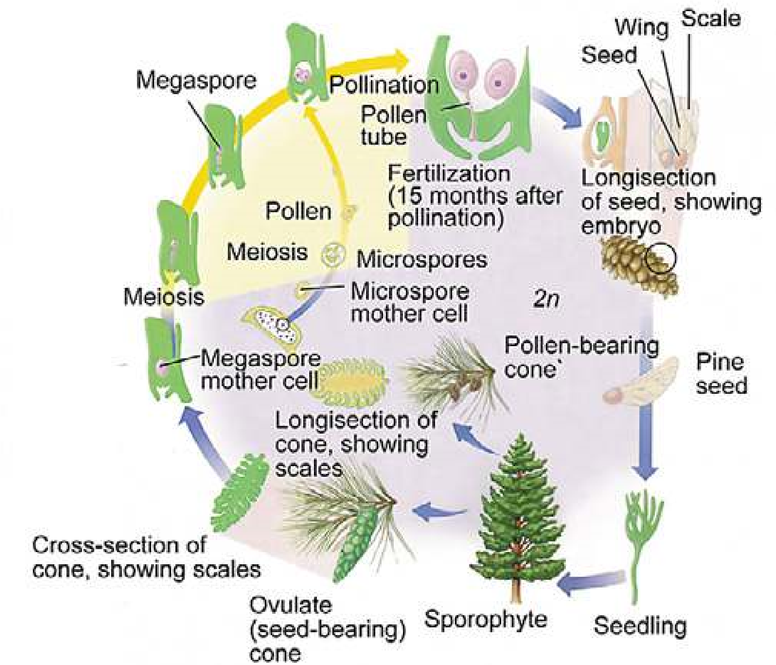

*Fig.9.21 Life Cycle of Pinus*

#### Class Angiospermae

The term angiosperms literally means “enclosed seeded” (Angio=close Sperm = seed). In these plants fertile leaves bearing ovules are folded and joined at the margins to form ovaries. The ovary after fertilization is changed into a fruit, containing seeds.

Angiosperms make up 235,000 of the 360,000 known species of plants. They are heterosporous, autotrophic plants. These are highly evolved of all the plants on the earth. The plants produce lowers, fruits and seeds.

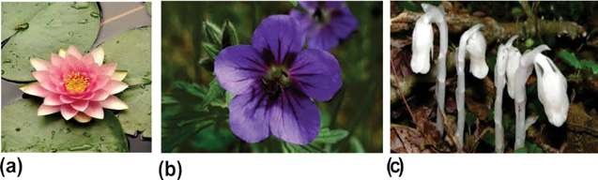

*Fig. 9.22 Some of the remarkable diversity of angiosperms is shown in these photographs. The species shown here are Dicots (a) Fragrant water lily, (b) wild geranium, (c) Indian pipe (a parasite) an angiosperm that lacks chlorophyll.*

#### Life Cycle of an angiospemic plant

The adult plant is a diploid sporophyte mostly diferentiated into roots, stem and leaves. At maturity it produces lowers. A lower is a modiied shoot which consists of a pedicel, thalamus or torus, and loral leaves (sepals, petals, stamens and carpels). Thalamus and loral leaves, especially the stamens and the carpels, are so modiied, that they do not even look like stem and leaves respectively. The sepals and petals are non- essential or non-reproductive parts, and stamens and carpels are the essential or reproductive parts of the lower.

The sepals and the petals protect the stamens and the carpels. They also attract insects for pollination. When the pollination is over, the sepals usually and the petals always fall of.

The anther contain microspore mother cells which produce haploid microspores through meiosis. Each microspore germinates to produce male gametophyte. Such microspores containing male gametophytes are called pollen.

The carpel consists of a basal broader part, the ovary, the style and the terminal part of the style, the stigma. The ovary contains ovules. The ovule consists of an integument (covering) and a tissue, the nucellus present inside.

After pollination, the pollen grain is transferred to the stigma. Here it germinates to form a pollen tube. The nucleus of the microspore divides by mitotic divisions to form two male gametes and the tube nucleus. At this stage of development, the pollen grain is called male gametophyte. In the meantime certain changes occur in the ovule leading to the formation of female spore (megaspore). The megaspore develops into female gametophyte. This consists of seven cells only. One of these cells is the egg or oosphere.

The pollen tube grows through the style, enters the ovule and then reaches the female gametophyte. Here it discharges the male gametes. The egg and one of the two male gametes fuse to form the oospore. The second male gamete fuses with the secondary nucleus to form endosperm nucleus **(double fertilization)**. The oospore develops into an embryo and endosperm nucleus develops into a multicellular nutritive tissue, the endosperm.

*Animation 9.2: Angiosperm Reproduction*

*Source and Credit:*

*amoebasister*

[*s*](http://amoebasisters.tumblr.com/)

#### Seed Formation

Meanwhile, the integuments of the ovule form testa and tegmen and ovary wall develops into the fruit. Seeds usually undergo a period of rest and then under suitable conditions, germinate and produce a seedling which gradually changes into a sporophyte (Fig. 9.23).

Thus an alternation of dominant sporophyte generation(2n) occurs with inconspicuous gametophyte generation(n).

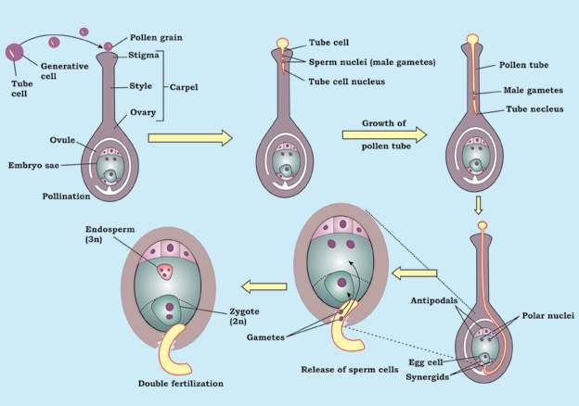

*Fig. 9.23 Life Cycle of on angiospermic plants*

##### Double Fertilization

Double fertilization is a special process found in Angiosperms. In this two male gametes fuses with two cells simultaneously. A male gamete (n) fuses with egg (n) to form a diploid zygote (2n) which develops later into an embryo and second male gamete (n) fuses with another female cell called fusion nucleus (2n) resulting into a triploid (3n) endosperm cell, which develops into food storing endosperm tissue. It is an important evolutionary advancement in which food storage in fertilized ovule is made only on fertilization i.e. formation of zygote. This actually helps the plant to economize its food resources.

*Animation 9.3: Double Fertilization*

*Source and Credit:*

*online.science.ps*

[*u*](https://online.science.psu.edu/)

#### Classiication of Angiosperms

The class Angiospermae is divided into two sub-classes, the Monocotyledonae (with one cotyledon) and the Dicotyledonae (with two cotyledons), according to the number of cotyledons in the embryo.

The plants included in the Monocotyledonae are called **Monocotyledonous** plants or Monocots. The plants included in the Dicotyledonae are called **Dicotyledonous** plants or Dicots. A few distinguishing characters of the two classes are given below:

*Fig. 9.24 Comparison of Dicot and Monocot*

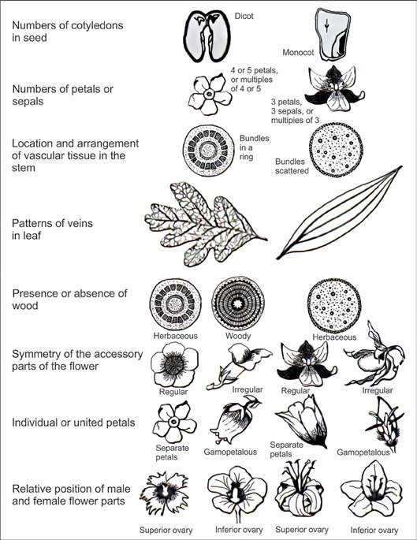

##### Angiospermic Familes

Some Angoispermic families are described below :

1. Rosaceae (Rose family). 2. Fabaceae (Pea family).

3. Mimosaceae ( Acacia family). 4. Solanaceae (Potato family).

5. Caeselpiniaceae {Cassiafamily). 6. Poaceae (Grass family).

**ROSACEAE (Rose Family):**

A family with about 100 genera and 2000 species is distributed over most of the earth. In Pakistan 29 genera and about 213 species are reported.

**Familiar Plants: Pyrus** (pear); **Rosa** (rose); **Malus** (apple); **Fragaria** (strawberry) etc.

*Animation 9.4: Rosaceae*

*Source and Credit:*

*loradesdehuelv*

[*a*](http://floradesdehuelva.com/florayvegetacion/familias/rosaceae/rosaceae.html)

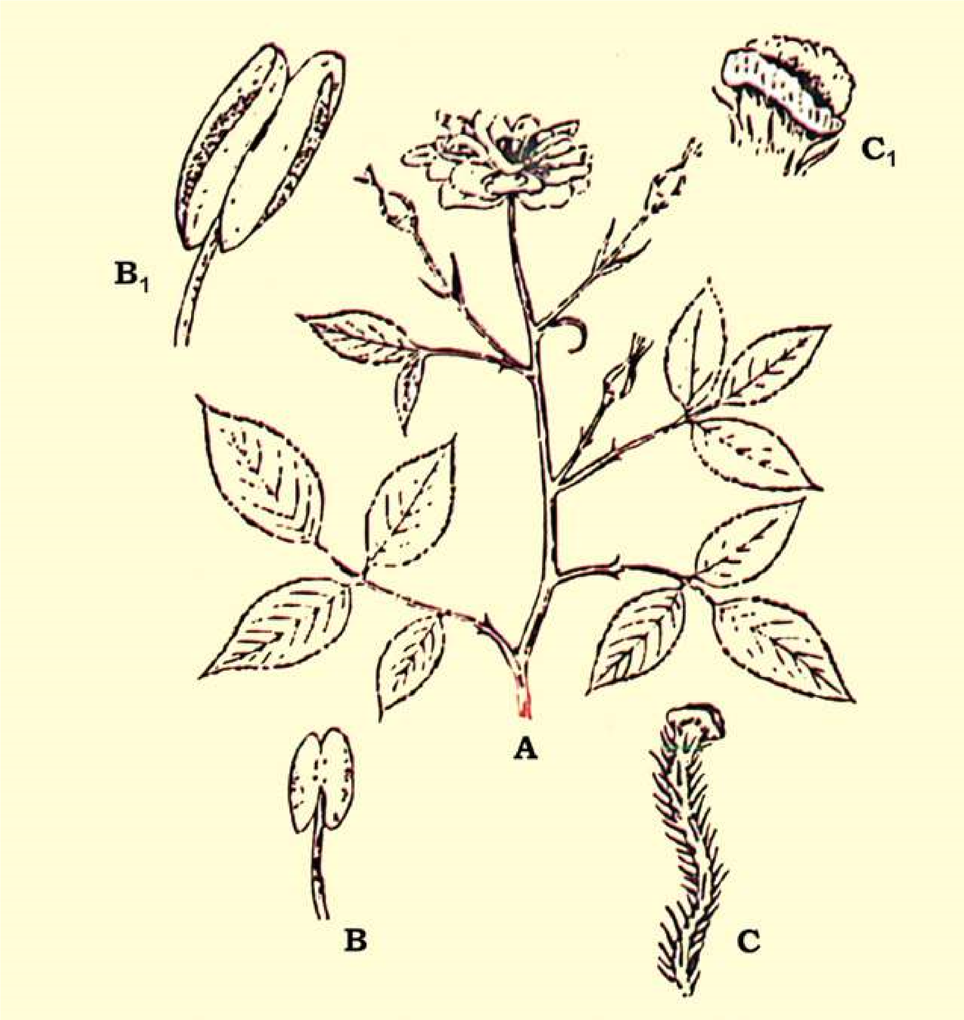

*Fig. 9.25 Rosaceae : A-twig; B-young stamen; B1-enlarged open anther, showing pollen in it; C-style hairy and stigma bilabiate; C1enlarged bilabiate stigma.*

##### Vegetative Characters

Plants are trees, shrubs and herbs. Stem of the shrubby plants usually have spines. Leaves are alternate, rarely opposite, simple or compound, with paired stipules, which are sometimes adnate to the petiole; spines may also occur on the rachis.

###### Floral Characters

Inlorescence is variable, solitary or may be racemose or cymose cluster. Flowers are mostly bisexual, and actinomorphic, often perigynous to some degree, usually showy and scented. **Calyx:** 5 sepals rarely 4, united at the base. **Corolla:** Petals 5, or numerous in multiple of 5, which are free rosaceous, large and showy. **Androecium:** Numerous stamens, sometimes only 5 or 10. **Gynoecium** is of 1 to numerous separate carpels or variously united, ovary generally superior sometimes inferior; **Placentation** basal, when the carpel is one or apocarpous, but axile when the carpels are many and syncarpous (fused).

**Economic Importance :** Economic importance of this family is great in providing the pleasure and welfare to mankind. The members of this family are important in temperate regions for fruit and ornamentals. Perhaps they rank third in commercial importance in the temperate zone among the families of lowering plants.

Important fruits are Apple, Pear, Peach, Almond, Apricot, Strawberry, etc.

A large number of plants are ornamental and are grown in gardens for their beautiful and scented lowers. The most widely cultivated genus for decorative purpose is Rosa, Rose which has been grown in gardens since ancient times and whose named cultivars are now numbered in thousands. Many other genera are also grown for their beautiful lowers in the parks and gardens.

The branches of *Crataegus* provide excellent walking sticks and wood. The wood of *Pyrus pastia* is used for making tobacco pipes.

In Asian countries the petals of common rose usually called gulabs are used in making gulkand, and are also used in extraction of an essential oil (rose oil) used as perfume, when distilled with water the petals give Rose-water or Ark-Gulab, which is used for curing eye disease, and for many other purposes.

###### SOLANACEAE: Night Shade or Potato Family

It is family of about 90 genera and 2000 species of tropical and temperate distribution. In Pakistan 14 genera and about 52 species are reported, Nasir (1985).

**Familiar Plants:** *Solanum tuberosum* (Potato), *Nicotiana tabacum* (Tobacco), *Lycopersicum esculentum* (Tomato), *Capsicum frutescens* (Red pepper).

**Vegetative Characters :** Plants including in this family are herbs, shrubs, sometimes trees or vines. Stem is hairy or prickly. **Leaves** are alternate or rarely becoming opposite in the loral region, simple, petiolate, rarely sessile.

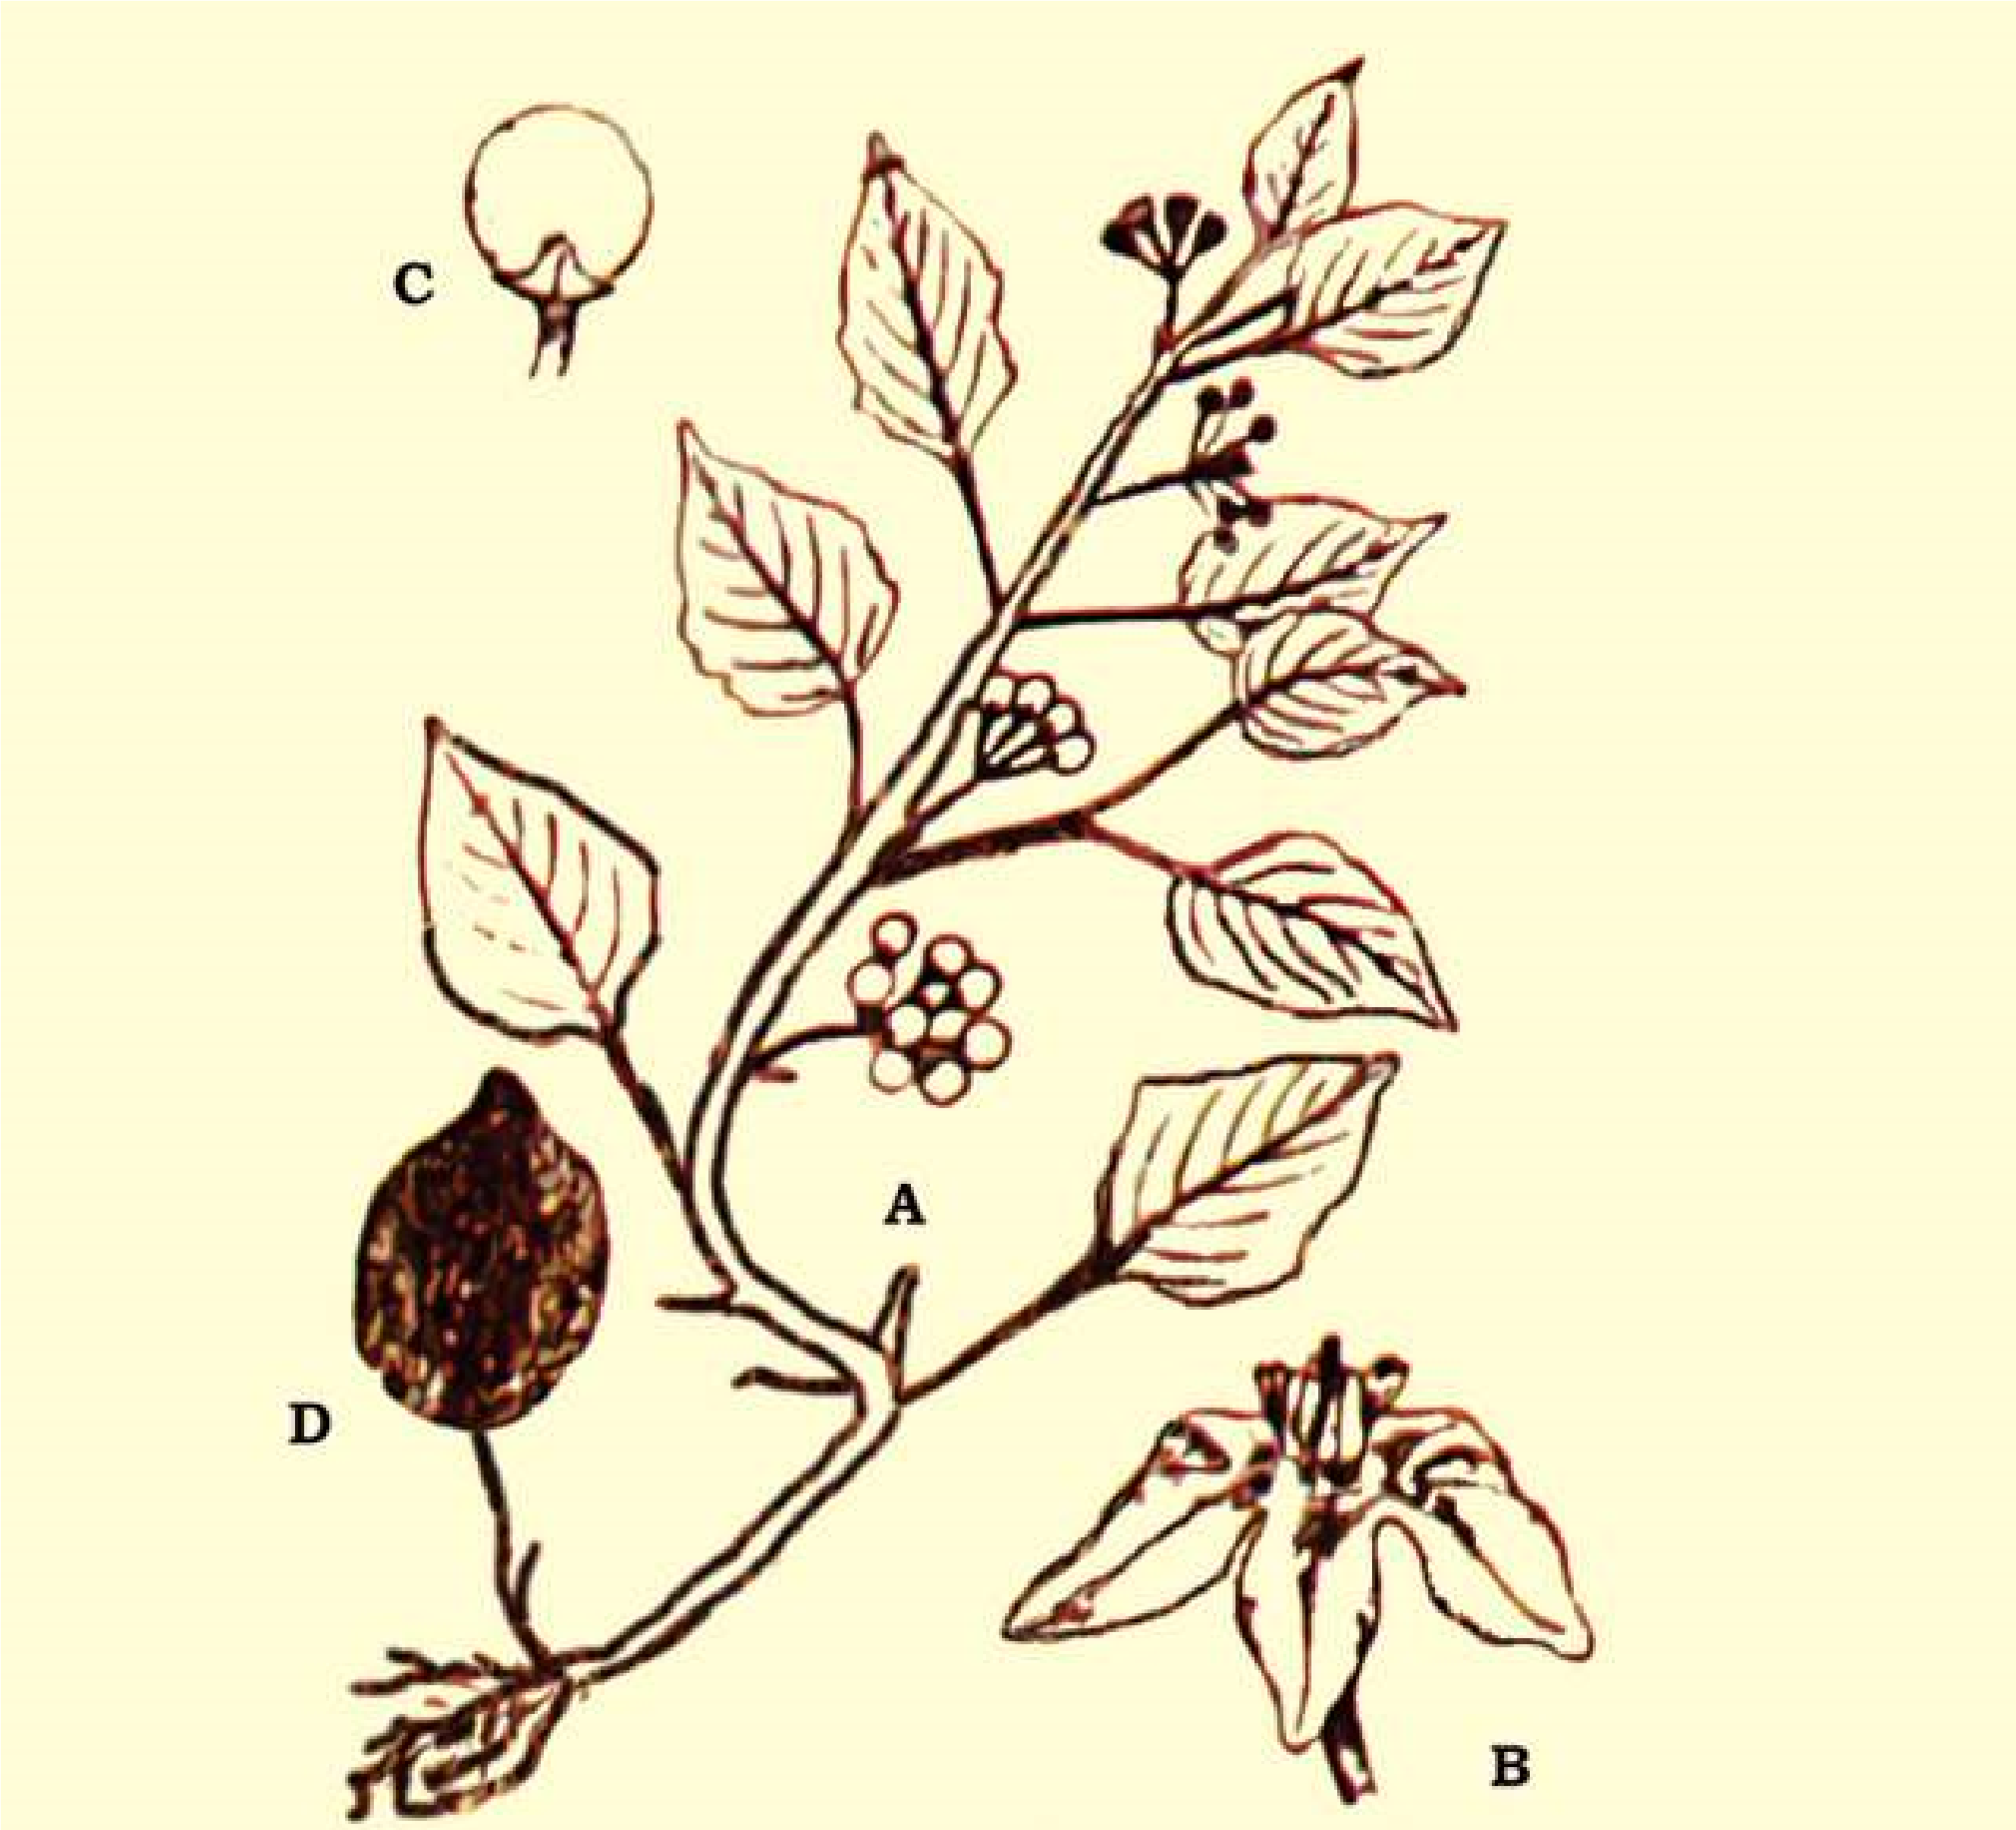

*Fig. 9.26 Solanaceae : Solarium nigrum, A - twig, B-Flower C-fruit, D-seed*

#### Floral Characters

**Inlorescence:** Typically an axillary cyme or combination of cyilies, sometimes helicoids, or axillary umbellate cymes. **Flowers:** Mostly bisexual, usually actinomorphic or weakly zygomorphic, hypogynous, usually pentamerous. **Calyx:** United 5 sepals, usually persistant. **Corolla:** United 5 petals, corolla rotate to tubular. Androecium: Stamens 5, free but inserted on the corolla tube (epipetalous) rarely stamens 4 and didynamous (arranged in two whorls of 2 each). **Gynoecium:** A compound pistil of 2 united carpels; ovary obliquely placed, superior, bilocular, or imperfectly 4-locular by false septum; **Placentation** axile.

**Economic Importance :** Members of the family Solanaceae provides drugs and food, some are weedy, some are poisonous, and others are handsome ornamentals. The most important plant in the family is *Solanum tuberosum* (Potato-white or Irish Potato). In Ireland people are completely dependent on Potatoes.

.

*Lycopersicum* *esculentum* (tomato), the favorite home garden vegetable, was once believed to be poisonous.

Other important food plants are Solatium metangena (egg plant or brinjal). The fruit of *Capsicum annum* and *Capsicum* *frutescens* are rich in vitamin C and A, are used as condiment. *Physalis* (GroundCherry) produces an edible fruit enclosed in a bladder like persistent calyx, the husk, giving the name husk tomatoe.

Another plant of great commercial value is *Nicotiana tabacum* the leaves of which are dried and made into tobacco, which is used in making cigarettes. Many members of this family yield powerful alkaloids, e.g. *Atropa belladona, Datura* which are rich in atropine and daturine respectively are used medicinally.

Many plants are cultivated in the gardens for their beautiful lowers, these includes *Petunia, Nicotiana, Cestrum* and *Solanum* etc.

##### FABACEAE: (Papilionaceae) Pea Family

A family of about 400 genera and 9000 species, the members of this family occurs all over the world, but particularly in the warm temperate regions. In Pakistan about 82 genera and about 587 species have been reported.

**Familiar Plants:** *Lathyrus odoratus* (Sweet pea), *Arachis hypogea* (Peanut), *Cicer arietinum* (Chick Pea) and *Dalbergia sissoo* (Shisham).

**Vegetative Characters :** Habit: Trees shrubs or herbs. Stem: Herbaceous, or woody or climber by tendrils (wiry, coiled thread like structures). Leaves: Compound or rarely simple, sometimes partially or completely modiied into tendrils, alternate, stipulate; stipules mostly leafy.

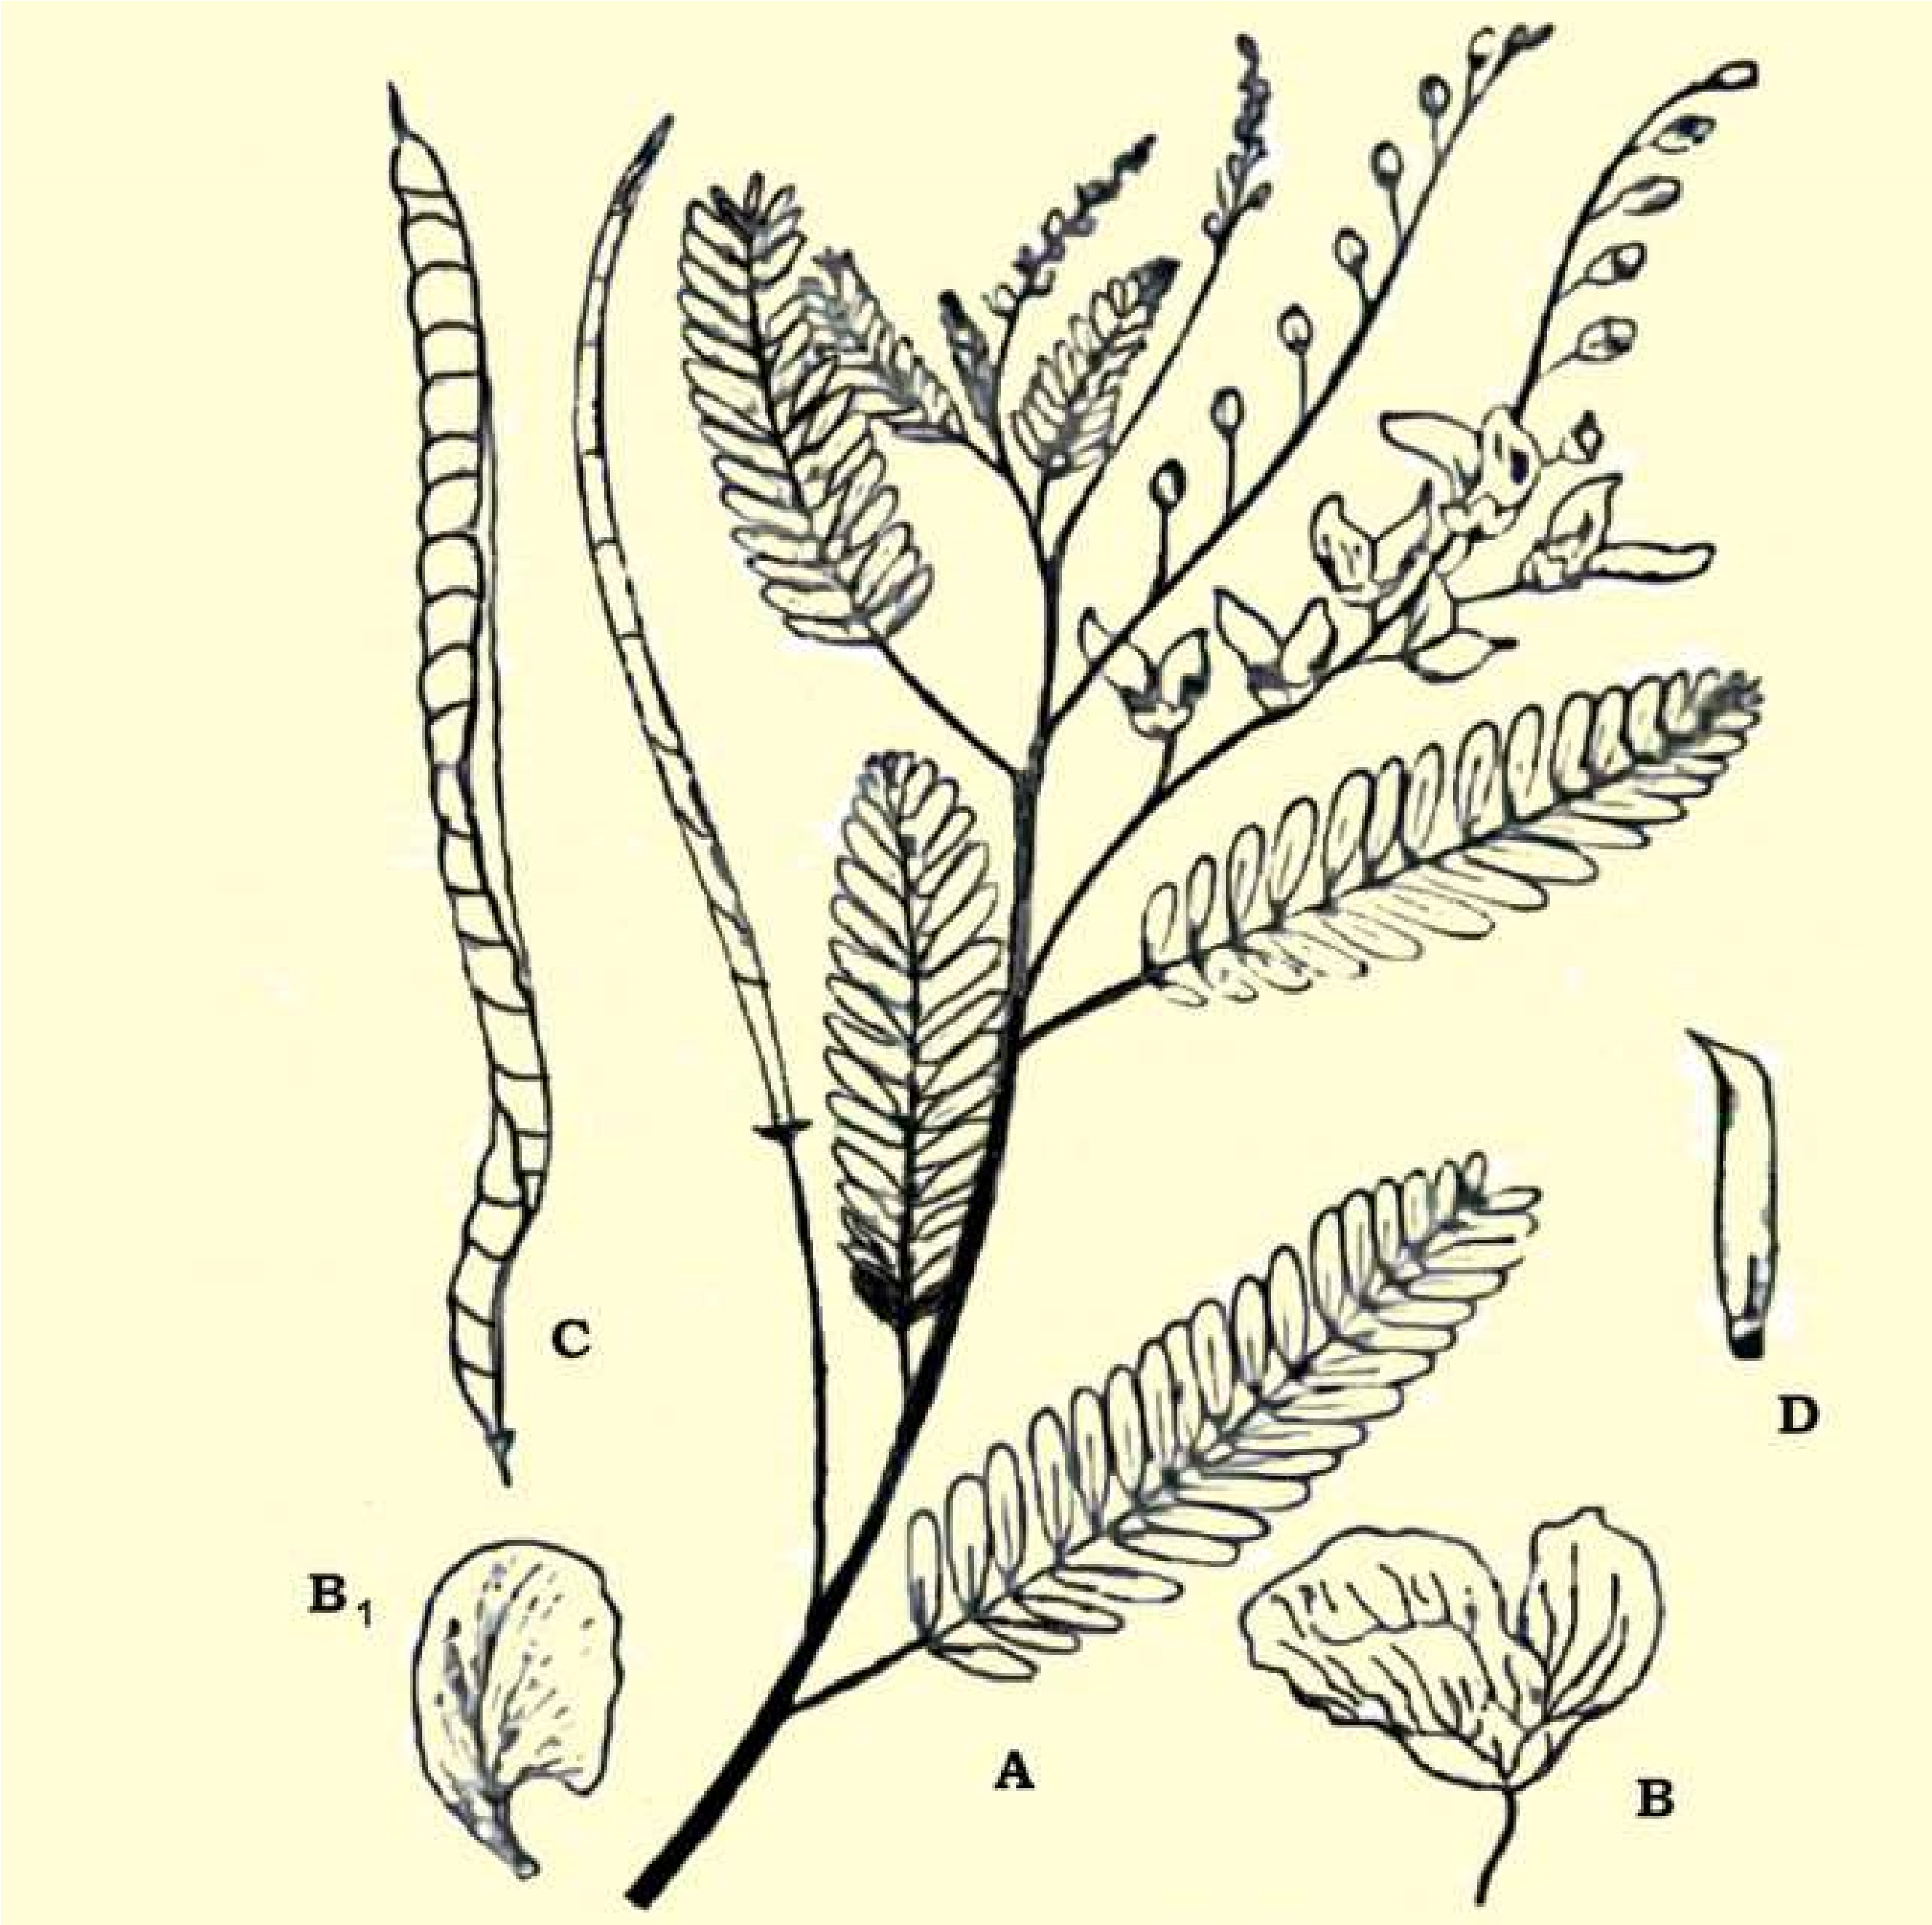

*Fig. 9.27 Fabaceae (Papilionaceae): Sesbania sesbar; A-twig; B-lower; B1 standard verillium; C-fruit a legume; D-carpel*

**Floral Characters :** **Inlorescence:** Racemose or solitary axillary. **Flowers:** Bisexual, zygomorphic, bracteate, pedicellate, perigynous, pentamerous and papilionaceous. **Calyx:** 5 sepals, more or less united in a tube, mostly hairy. **Corolla:** Papilionaceous; petals 5, usually clawed, dissimilar; the upper posterior petal is large and conspicuous and is called standard or vexillum, 2-lateral ones free called wings and 2 anterior inner most that fuse to form a boat-shaped structure called the keel or carina. **Androecium:** Stamens 10, mostly diadelphous (united by their ilaments in 2 groups), 9 fused to form a sheath round the pistil, while 10th posterior one is free. **Gynoecium:** A simple pistil, 1- carpeled, with 1-locule; ovary superior; ovary and style long, style bent at is bar, **placentation** (mono carpellary) marginal. **Fruit:** Usually a legume or pod, showing a great variety of form in various species.

**Economic Importance :** The family is of considerable importance as a source of high- protein food, oil, and forage as well as ornamentals and other uses. Main importance lies in the pulses, belonging to this family, which are used as food, some important and common species of pulse yielding plants are: Gram, Pea, Kidney bean. These pulses are rich in protein contents.

*Medicago sativa* Alfafa is one of the world’s best forage crop for horses. *Vicia, Melilotus* and *Trifolium* are also cultivated as main fodder crops. Many trees of this family provide excellent timber for building, furniture and fuel. Main timber plants are *Butea, Dalbergia* etc.

Seeds of Arachis hypogea peanut are edible and also used for extraction of peanut oil which after hydrogenation is used as a vegetable oil. Indigo dyes are obtained from Indigofera tinctoria and Butea monosperma, yielding yellow dye from lowers.

Many plants of this family are important for medicines: these include Glycyrrhiza glabra for cough and cold, and Clitoria tematea is used against snake bite. The red and white seeds of Abrus precatorious are used by jewellers as weights called “ratti”. Some important ornamental plants include Lathyrus, Lupinus, Clitoria, Butea etc.

##### CAESALPINIACEAE: Cassia Family

This family includes about 152 genera and about 2300 species. In Pakistan the family is represented by 16 genera and about 60 species.

**Familiar Plants:** Tamarinaus indica, Cassia istula, Bauhinia veriegata.

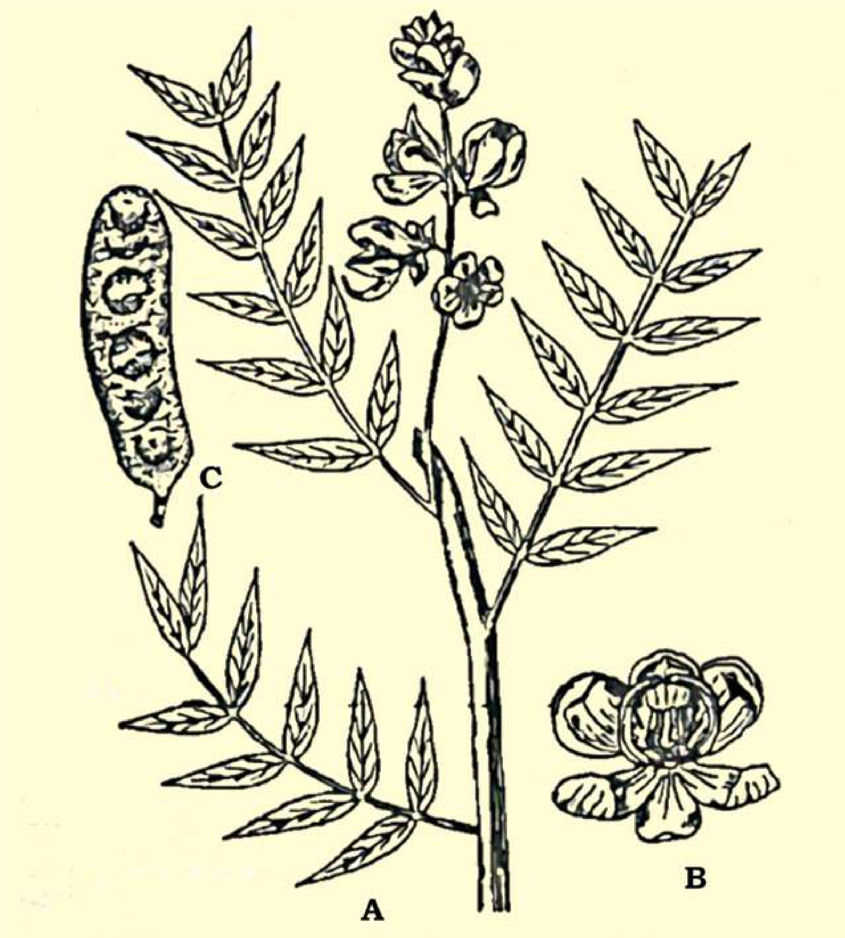

*Fig. 9.28 Caesalpiniaceae : Cassia senna; A twig, B-lower; C-fruit*

**Vegetative Characters Habit:** Mostly trees or shrubs, some are woody climbers; rarely herbs. Stem: Erect, woody, herbaceous, or climbing. Leaves: Compound, pinnate, very rarely simple, stipulate

**Floral Characters :** **Inlorescence:** Axillary or terminal raceme or panicle or spikes, rarely cymose; showy. **Flowers:** Bisexual, zygomorphic, rarely actinomorphic, perigynous. **Calyx:** Sepals 5, free or connate at base, often colored. **Corolla:** Mostly 5 petals, free. **Androecium:** Stamens 10 or fewer, rarely numerous, free or variously united. **Gynoedum:** A simple pistil 1-carpel; ovary superior, unilocular; **placentation** marginal; stigma simple. **Fruit:** Legume

**Economic Importance :** The family is of great importance. Some plants are ornamental, some have medicinal importance, a few have food and other values.

The leaves of *Cassia alata* are used to cure ring worm and skin diseases. *Cassia senna* and *C*. *obovata* are cultivated for the leaves which yield the drug Senna, which is the base for a laxative. Oil extracted from the seeds of *Cynometera caulilora* is applied externally for skin diseases.

Common ornamental plants are *Bauhinia variegata* (Kachnar), *Cassia istula* (Amaltas), *Parkinsonia,* etc.

The leaves and lower’s bud of *Bauhinia variegata* are used as vegetable. The acidic fruit of *Tamarindus* *indica* are edible and are rich in tartaric acid. The bark of *Bauhinia and Tamarindus indica* is used in tanning. The heartwood of *Haematoxylon* (Longwood) yield the dye Haematoxylin.

**MIMOSACEAE: Mimosa or Acacia Family :**

A family of about 56 genera and about 2800 species. In Pakistan it is represented by 11 genera and 49 species, of these only 4 genera and 18 species are native and rest are introduced.

**Familiar Plants**: *Acacia nilotica , Albizzia lebbek, Mimosa pudica* Touch me not, *Prosopis glandulosa, P. cineraria.*

**Vegetative Characters :** Habit: Mostly trees or shrubs, rarely climbers or herbs. Most of them are xerophytes. Stem: Mostly woody. Leaves: Pinnate by compound, alternate, stipulate, stipules modiied into thorns.

**Floral Characters :** **Inlorescence:** Spike like or head or umbel, rarely racemose or globose umbels. **Flowers:** Bisexual, Actinomorphic, hypogynous to slightly perigynous, bracteate. **Calyx:** Usually sepals 5, generally fused, toothed or lobed. **Corolla:** petals 5, free or fused; corolla lobed. **Androecium:** Stamens 5 to numerous, free, or adnate to the base of corolla. **Gynoecium:** A simple pistil of 1 carpel, ovary unilocular, superior; ovules many, placentation marginal. **Fruit:** A legume dehiscent or indehiscent.

**Economic Importance :** Many trees of this family including species of *Acacia, Albizzia* and *Xylia* provide commercially important wood, which is used for construction purpose or for furniture or as a fuel. The wood of *Albizzia* lebbek is used in cabinet work, and railway carriages.

Arabic gum is obtained from *Acacia nilotica* and *A. Senegal.* Katha a dye is obtained from *Acacia catechu.* The tender leaves of *Accacia nilotica* are used as blood puriier.

Some common garden plants grown for their beautiful lowers are *Mimosa pudica* and **Acacia melanoxylon**. A few species of *Prosopis* are planted in the arid zones for breaking the wind pressure.

*Animation 9.5: MIMOSACEAE*

*Source and Credit:*

*kidzsearc*

[*h*](http://www.kidzsearch.com/wiki/Mimosa_pudica)

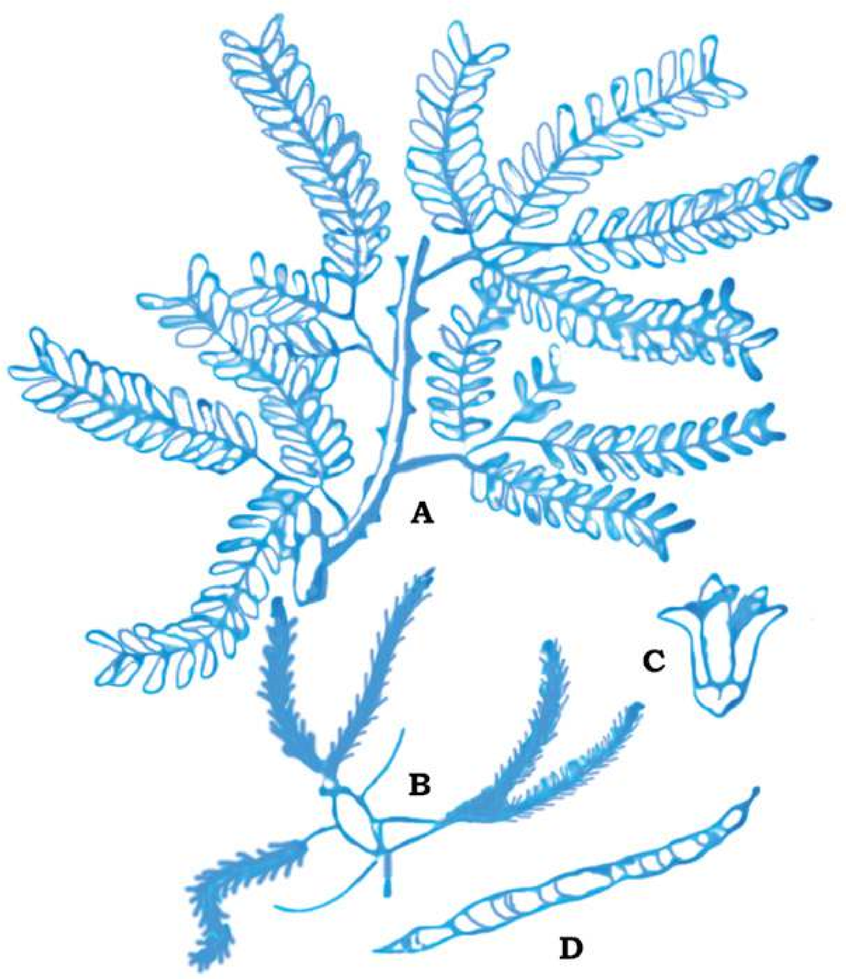

*Fig. 9.29 Mimosaceae : P rosopsiscineraria; A-twig, B-inloresence; C-lower; -D-fruits*

**POACEAE: (Gramineae) Grass Family**

Distributed throughout the world wherever vascular plants can survive. It includes about 600 genera, 10,000 species. In Pakistan it is represented by 158 genera and 492 species.

The traditional family name Gramineae takes its name from the Latin Grammar which was used as a ‘generic’ name for certain grasses, is permitted by the International Code of Binomial Nomenclature, which also provides for the use of Poaceae, based upon the type genus *Poa* Linn.

**Familiar Plants:** *Triticum vulgare,* Wheat; *Zea mays*, Com; *Avena sativa*, Oats; *Oryza sativa*, Rice; *Bambusa,* Bamboo; *Saccharam oicinarum* Sugar Cane etc.

**Vegetative Characters :** Habit: Annual or perennial, herbs. Stem: Jointed usually hollow, at the internodes, closed at the nodes. Leaves: Solitary at the nodes, sometimes crowded at the base of the stem, alternate, exstipulate, ligulate, mostly sessile, leaf-base mostly sheathing, simple.

**Inlorescence:** Mostly compound composed of units called spikelets which are variously arranged (indense clusters as in wheat, compound spike, or loosely on branched axis-as in oats , spikelets consisting of bracts, arranged along a slender axis (called rachilla) the two lower bracts (called glumes) which are empty; the succeeding lemmas enclosing a lower and opposed by a hyaline scale called palea. The Whole (lemma, palea, and lower) termed as loret; the glumes or lemmas often bearing one or more stif bristles (called awns); this basic pattern of spikelet structure is consistent throughout the family. Spikelets of grasses vary widely in diferent genera, particularly as to number of fertile lorets in each, and deposition of sexes with them.

**Flowers:** Usually bisexual, sometimes unisexual, small and inconspicuous, sessile, bracteate, incomplete, zygomorphic, hypogynous. **Perianth:** Absent or represented by 2, (rarely 3), minute hyaline or leshy scales called lodicules. **Androecium:** Stamens 1 to 6, usually 3. with delicate ilaments. **Gynoecium:** A compound pistil of 3 united carpels, anthers versatale, though only one is functional free; stigmas usually large feather like. Fruit : Grains or Caryopsis (caryopsis a dry, indehicent fruit in which fruit wall (pericarp) is completed, fused with seed coat).

**Economic Importance :** Economically family Poaceae has greater importance than any other family of lowering plants. It has great economic importance to both man and animals. Cereals and millets which constitute the chief food stuf of mankind, belongs to this family. Most of the fodder crops, which are equally important to domestic animals, also belong to this family.

Plants providing food for man includes: *Triticum sp*. (wheat), *Avena sativa* (Oats), *Zea mays* (Corn, Maize), *Oryza sativa* (Rice), *Hordeum vulgare* (Barley), *Secale cereale* (Rye), *Penisetum typhoideum*; *Sorghum vulgare* etc.

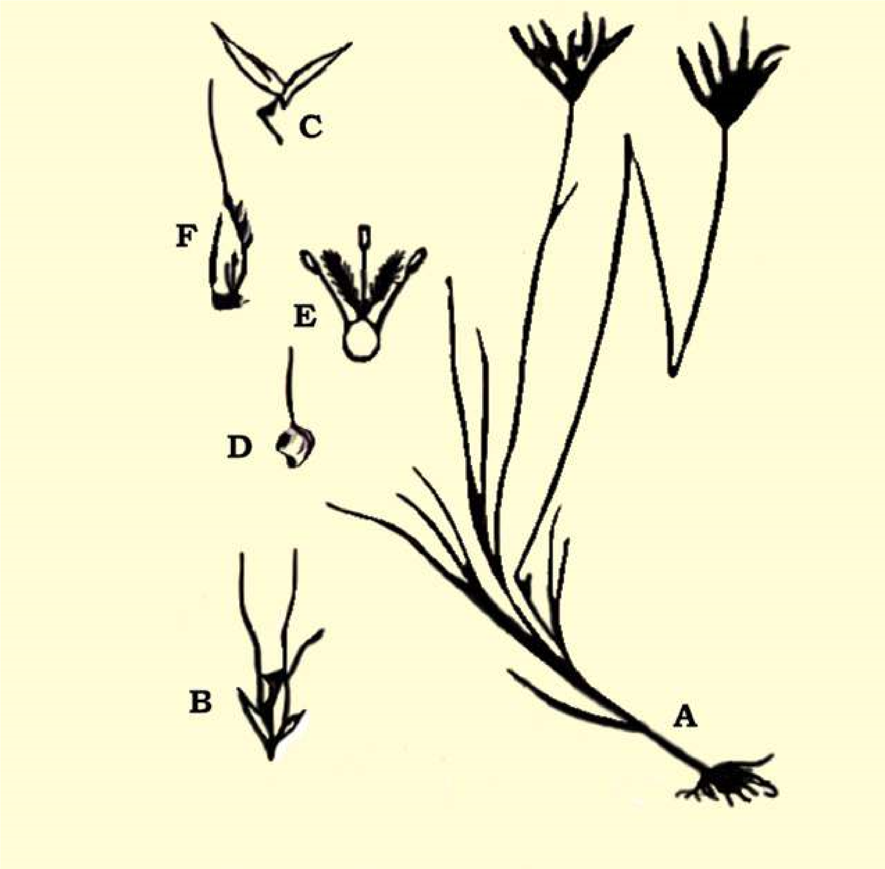

*Fig. 9.30 Poaceae (Gramineae): Chloris barbata: A nabit; B-spikelet; C-glumes; D-fertile lamma, E-lower; F-fruit;*

The dried stem and leaves of the cereal crops are used as fodder for the cattle. Sugar is obtained from the juice of *Saccharum oicinarum* (Sugar Cane). Many grasses are used in the lawns e.g. *Agrostis, Poa*, *Festuca* etc. and have ornamental signiicance.

*Bambusa* (Bamboo) are used as building material for the thatching huts, making boats, carts, pipes etc. and the split stem are woven into mats, baskets, fans, hats, course umbrella. Leaves are also given to horses as a cure of cough and cold etc. Certain grasses yield aromatic oils, e.g. Cymbopogon citratus (lemon grass) which yield lemon grass oil is used in perfumes and soap industry and for making infusions. Some species of the grasses are used in making papers.

Ethyl alcohol and many other kind of beverages are also prepared from cereals for example whisky from Rye, barley, corn and rum molasses from sugar cane. Fibers obtained from the leaves of *Saccharum munja* which is used in making ropes.

*Animation 9.7: Poaceae*

*Source and Credit:*

*next.c*

[*c*](http://www.next.cc/journey/language/grass)

##### EXERCISE

**Q1. Fill in the blanks.**

1. The sporophyte is __________ and_________ generation and the gametophyte is_______ and_______ .
2. The motile asexual reproductive cells are characteristics of _____ and are called______ .

1. The sexual reproduction is said to be oogamous or heterogamous if the two fusing gametes are-------------------.
2. In the stem of Monocotyledons the bundles are__________while in the stem of Dicotyledons they are___________ .
3. The double fertilization is the characteristic feature of_____.
4. Stem roots and leaves are the_______________parts and lowers, fruits and seeds are the :________ parts of the plant.
5. _______ is the phenomenon of the production of two kinds of spores in the plants.

(ix) The naked-seeded plants are included in the group_______. **Q.2 Short questions.**

1. (a) How are ferns better adapted to life on land than liverworts and mosses?
   1. Which of the following are nutritionally self supporting:
   2. Mature liverwort and moss gametophyte.
   3. Mature liverwort and moss sporophyte.
2. (a) The chances of survival and development of wind-blown pollen grains are much less than those of spores of Adiantum. Comment on this statement.
   1. Account for the fact that megaspores are large and microspores are small.
   2. What important advances have angiosperms made towards the seed plant life? (iii) Write a note on the alternation of generations.

(iv) What is the importance of the following?

(i) Seed. (ii) Double fertilization. (iii) Heterospory.

1. Pick and match the following:
   * 1. Fem sporophyte involves vegetative parts of plants.
     2. The moss plant is the irst cell of sporophyte.
     3. The gamete is the last cell of gametophyte.
     4. The spores are asexual reproductive cells. (v) Vegetative reproduction are haploid cells.
     5. The oospore is gametophytic generation.
     6. The gamete is a diploid generation.
     7. The spore mother cell is the irst cell of gametophytes. (ix) The spore with naked seeds.

(x) Gymnosperms are the plants divides by reduction division to form haploid spores.

1. Sketch and label a fertile pinnule and a sporangium of Adiantium.

**Q.3 Extensive Questions**

1. To what does alternation of generations refer in the plants? Deine sporophyte and gametophyte. With which stage is an adult animal comparable? How are they reproductively dissimilar?

1. What is a seed? Why is the seed a crucial adaptation to terrestrial life?

1. Describe evolution of leaf and its importance in vascular plants.
2. Disciiss evolution of seed and it signiicance.

1. In what way do the lowering plants difer from the rest of the seed plants? What is the stigma? Is fertilization in angiosperms direct or indirect? From what tissue does angiosperm fruit develop?

1. What two classes comprise the angiosperms? How do the two classes structurally difer from one another? Which class derived from the other? Explain.